**Module/Week3 –**Assignment 2

Topic**:**

Structured Query Language; Join Operations; Beyond Simple SELECT Queries

Student’s Full Name: LIBIN NAITHELLOOR GEORGE

Course Title: Data Warehousing and Analytics in the Cloud

Term name and year: Fall 2023

Submission Week: [example, Week 3- Assignment 2]

Instructor’s Name: Dr.Nayem Rahman

Date of Submission: 27 July 2024

**Q1. Show the screenshot of a successful installation of MySQL Software and MySQL Workbench with the latest version on your machine. Show the screenshot of the database “Worker”created.**

Link: https://dev.mysql.com/downloads/file/?id=508935 NOTE: As part of MySQL Software installation, make sure you have installed MySQL Workbench. Using the MySQL Workbench, create a database called Worker. I repeat, the database must be named “Worker”. Use the below command: CREATE DATABASE Worker; Check if the database was created. Use with the following SQL command: SHOW DATABASES; Show the screenshot of the execution of the above statements and results.

## MYSQL Installation Screenshot.

|  |
| --- |
|  |
|  |

## MYSQL WorkBench Installation

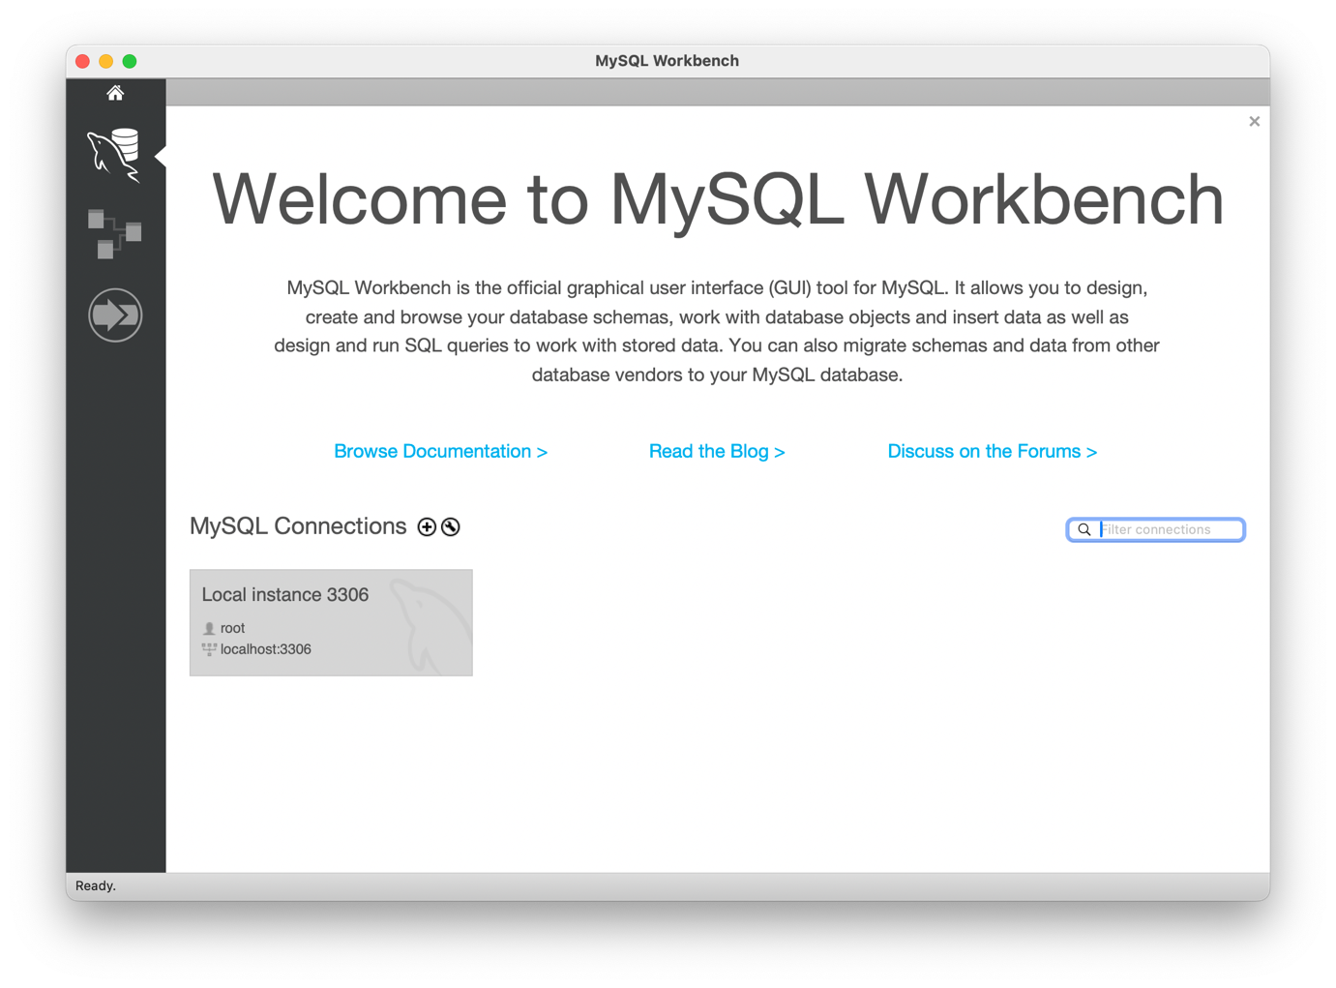

## Database Creation

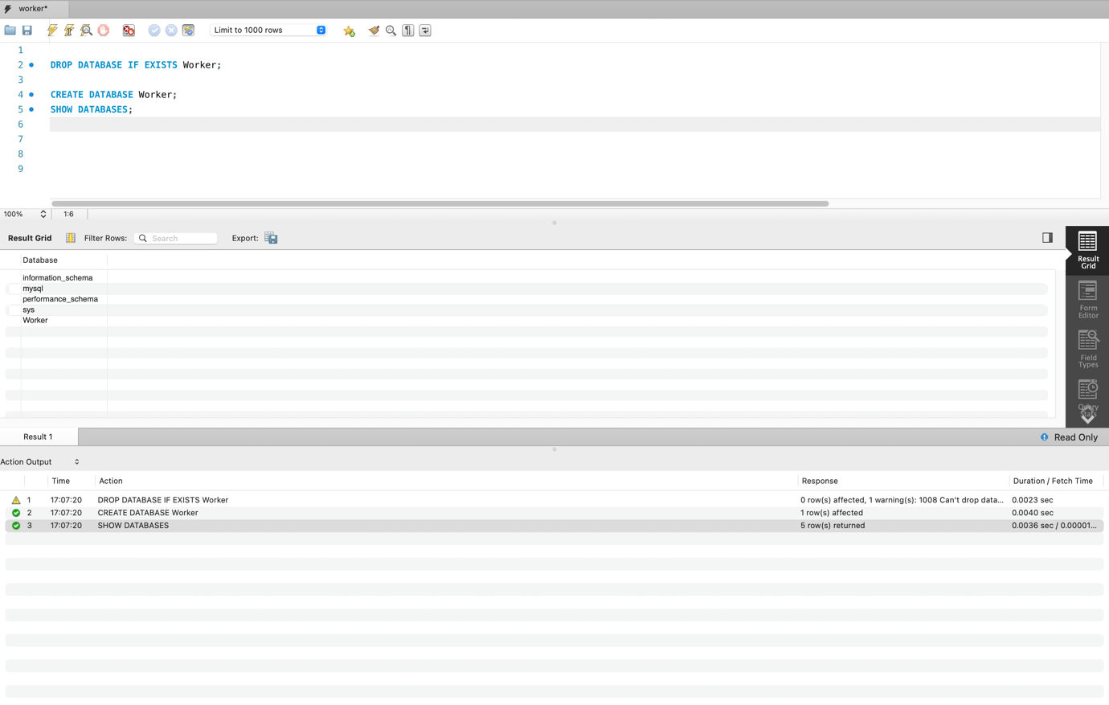

**Q2. . Create the Department table in the Worker database (table must be based on Physical Model Provided in the Assignment folder).**

**(a) Columns, Primary Key (PK), Data Type & length, and NULL/NOT NULL need to be implemented, as provided in the Physical Model.**

|  |  |
| --- | --- |
|  | CREATE TABLE Department(  DepartmentID TINYINT NOT NULL,  DepartmentNm CHAR(30) NOT NULL,  PRIMARY KEY (DepartmentID)  ); |

**(b) Show the table definition (DDL) that you implemented.**

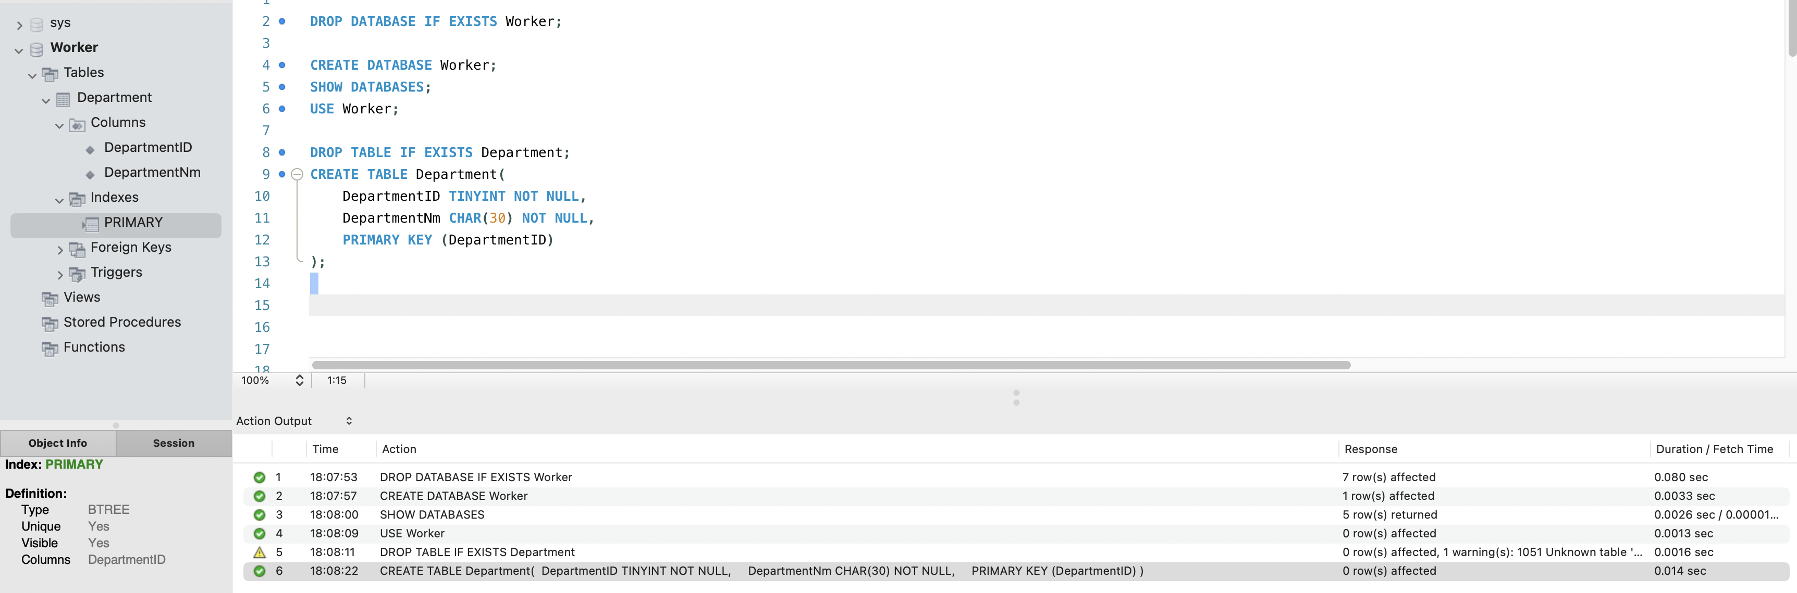

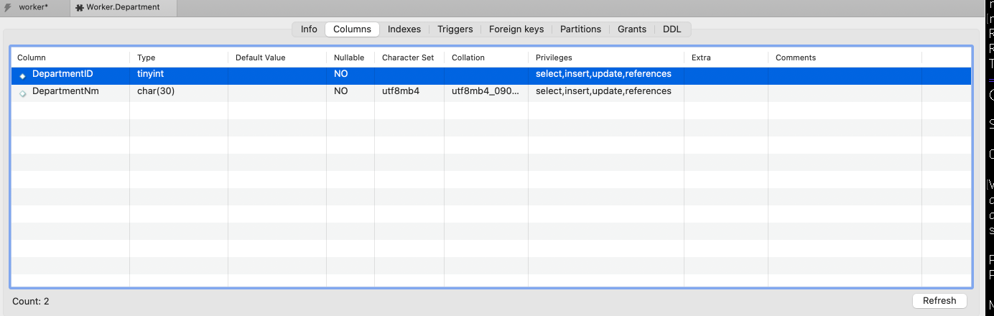

**(c) Insert the complete set of data provided in the Excel file (uploaded in the Assignment folder) and show the insert statements used.**

|  |
| --- |
| INSERT INTO Department(`DepartmentID`, `DepartmentNm`) VALUES  ( 1, 'Research & Development'),  ( 2, 'Production'),  ( 3, 'IT Support'),  ( 4, 'Operations'),  ( 5, 'Customer Service'),  ( 6, 'Purchasing'),  ( 7, 'Sales & Marketing'),  ( 8, 'Human Resource Management'),  ( 9, 'Accounting and Finance'),  ( 10, 'Legal'); |
|  |

**(d) Retrieve the data from the Department table by using the SELECT * statement and order by PK column(s). Show the output. Make sure you show the print screen of the complete set of the rows and columns. The rows must be ordered by PK column(s).**

|  |
| --- |
| SELECT * FROM Worker.Department ORDER BY DepartmentID; |

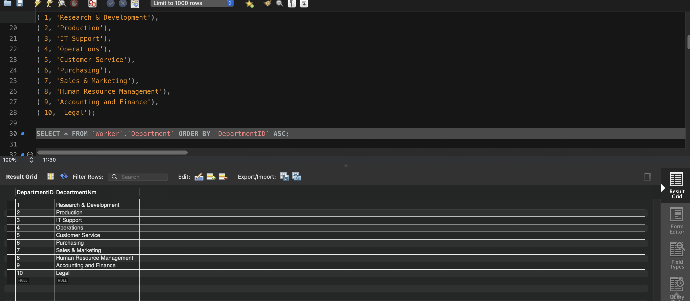

**Q3. Create the Employee table in the Worker database (table must be based on Physical Model Provided in the Assignment folder).**

**(a) Columns, Primary Key (PK), Data Type and length, and NULL/NOT NULL need to be implemented, as provided in the Physical Model.**

|  |  |
| --- | --- |
|  | CREATE TABLE Employee (  EmployeeID INTEGER NOT NULL,  DepartmentID TINYINT NOT NULL,  FirstName VARCHAR(20) NOT NULL,  LastName VARCHAR(20) NOT NULL,  Address VARCHAR(50),  PhoneNumberTxt VARCHAR(15),  HireDate DATE NOT NULL,  FOREIGN KEY (DepartmentID)  REFERENCES Department (DepartmentID)  ON DELETE CASCADE,  PRIMARY KEY (EmployeeID)  ); |

**(b) Show the table definition (DDL) that you implemented (not in a graphical view).**

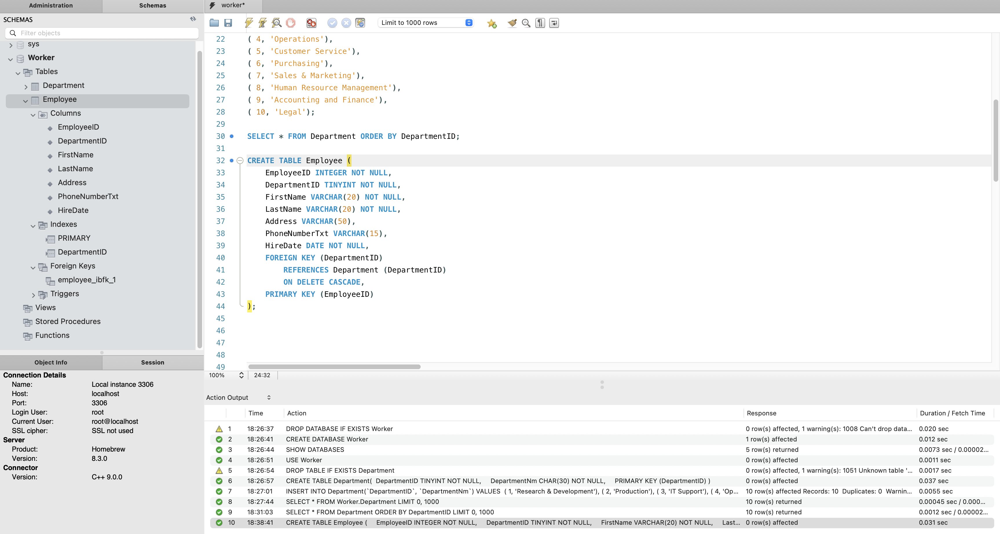

**(c) Insert the complete set of data provided in the Excel file (uploaded in the Assignment folder) and show the insert statements used.**

|  |
| --- |
| **INSERT INTO Worker.Employee (EmployeeID, DepartmentID, FirstName, LastName, Address, PhoneNumberTxt, HireDate)**  **VALUES (1, 2, 'Andy', 'Wong', '345 South Street', '(603) 555-6880', '2001-01-15'),**  **(2, 1, 'John', 'Wilson', '560 Broadway', '(518) 555-6690', '2017-03-19'),**  **(3, 3, 'Vivek', 'Pandey', '15 Mineral Drive', '(603) 555-4420', '2003-11-15'),**  **(4, 7, 'Nola', 'Davis', '15 Long Ave', '(478) 555-8822', '2016-03-23'),**  **(5, 8, 'Kathy', 'Cooper', '15 Hatter Drive', '(212) 555-9630', '2011-11-18'),**  **(6, 9, 'Tom', 'Harper', '64 Highland Street', '(212) 555-7755', '2010-04-11');** |

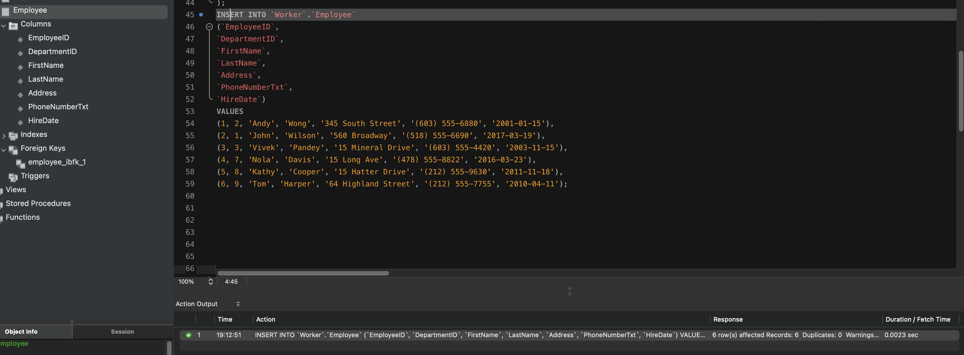

**(d) Retrieve the data from the Employee table by using the SELECT * statement and order by PK column(s). Show the output. Make sure you show the print screen of the complete set of the rows and columns. The rows must be ordered by PK column(s).**

|  |
| --- |
| **SELECT**  **\***  **FROM**  **Worker.Employee**  **ORDER BY EmployeeID ASC;** |

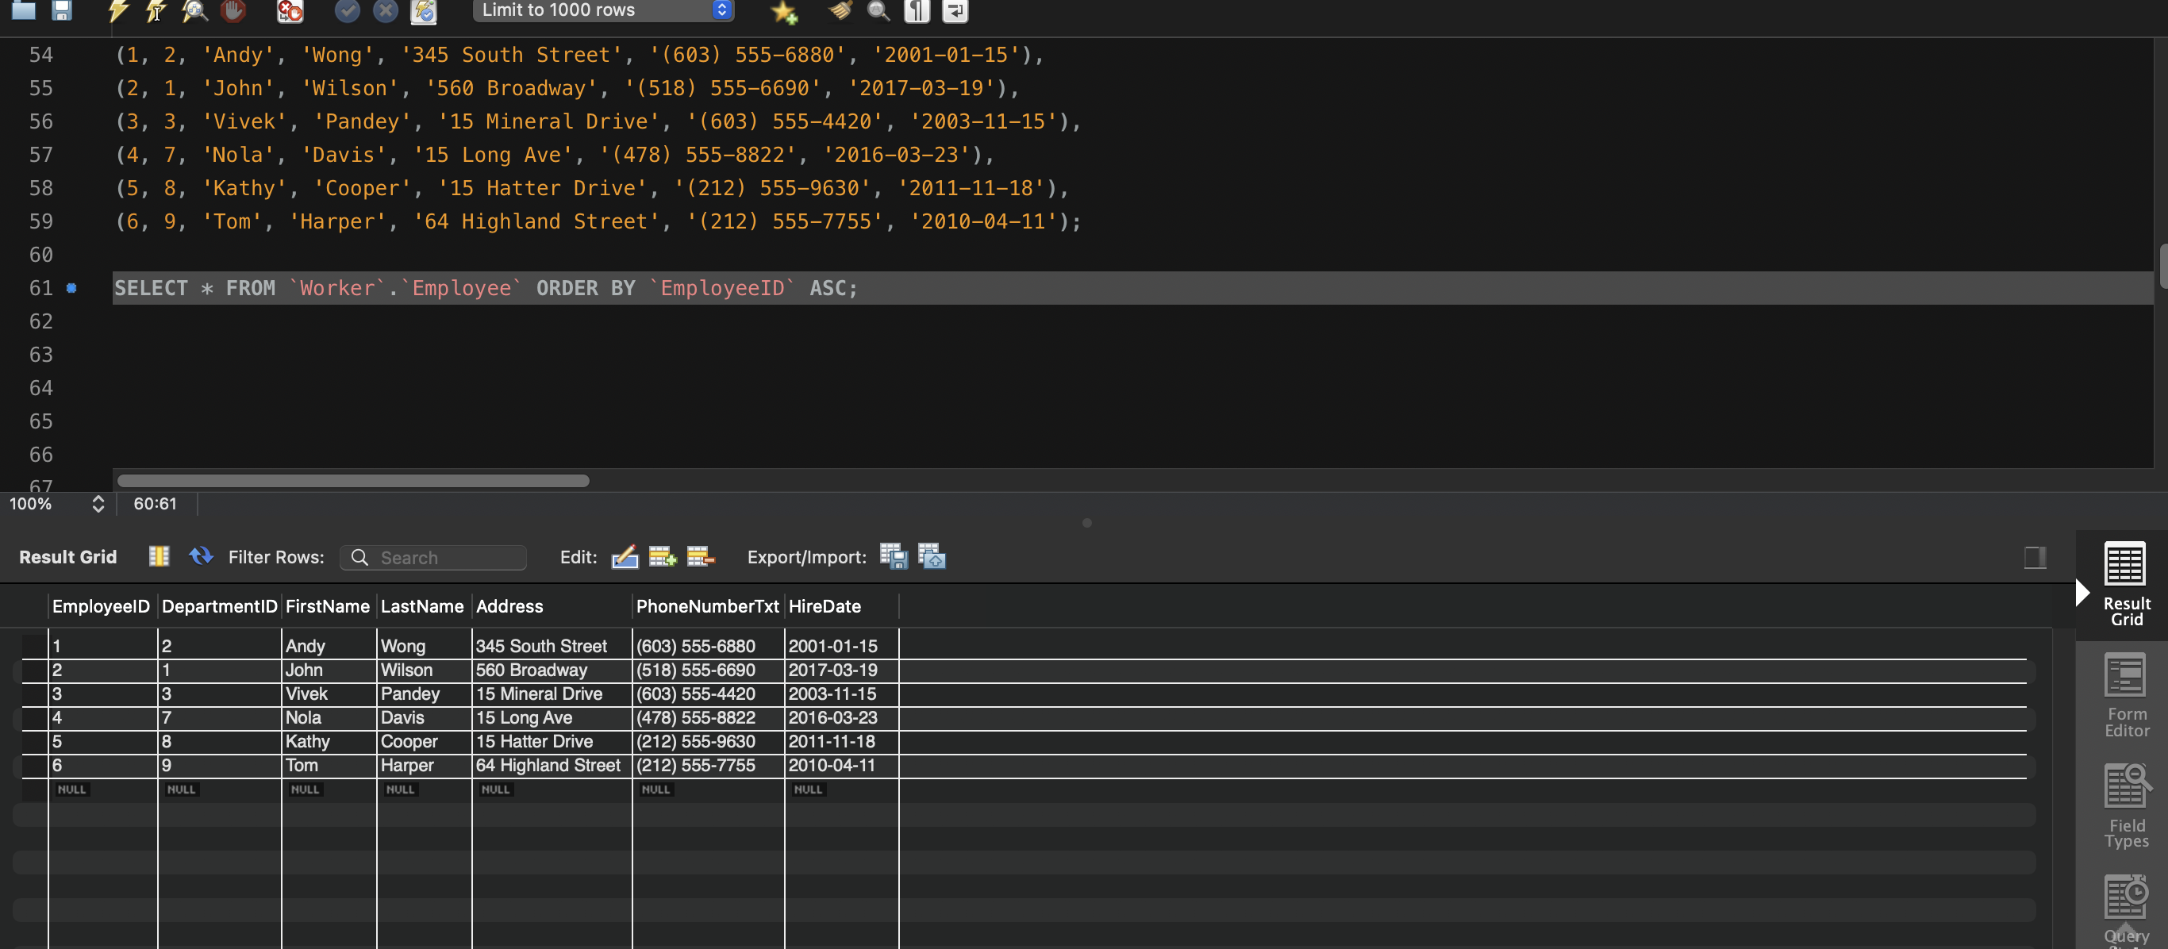

**Q4. Create the Equipment table in the Worker database (table must be based on Physical Model Provided in the Assignment folder).**

**(a) Columns, Primary Key (PK), Data Type & length, and NULL/NOT NULL need to be implemented, as provided in the Physical Model.**

|  |  |
| --- | --- |
|  | CREATE TABLE `Worker`.`Equipment` (  EquipmentID INTEGER NOT NULL,  EquipmentName VARCHAR(30) NOT NULL,  EquipmentCostAmount DECIMAL(13, 2),  PRIMARY KEY (EquipmentID)  ); |

**(b) Show the table definition (DDL) that you implemented.**

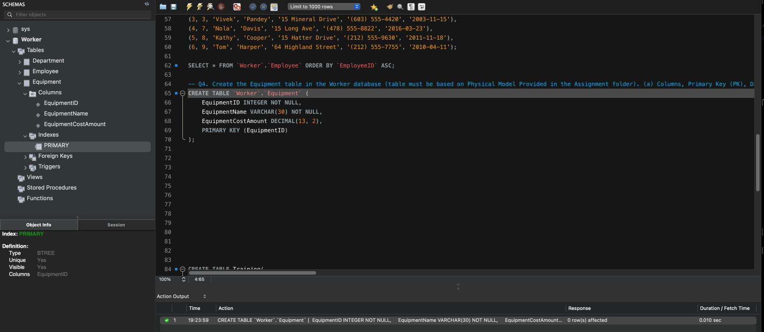

**(c) Insert the complete set of data provided in the Excel file (uploaded in the Assignment folder) and show the insert statements used.**

|  |
| --- |
| **INSERT INTO Worker.Equipment(EquipmentID, EquipmentName, EquipmentCostAmount)**  **VALUES**  **(1, 'Notebook Computers', 2500),**  **(2, 'Headsets', 500),**  **(3, 'Computer Monitor', 1000),**  **(4, 'Multi-Function Printers', 2000),**  **(5, 'Projector or a Big Screen TV', 1400),**  **(6, 'Servers', 5000),**  **(7, 'Internet Modem ', 110),**  **(8, 'Cell Phone', 900);** |

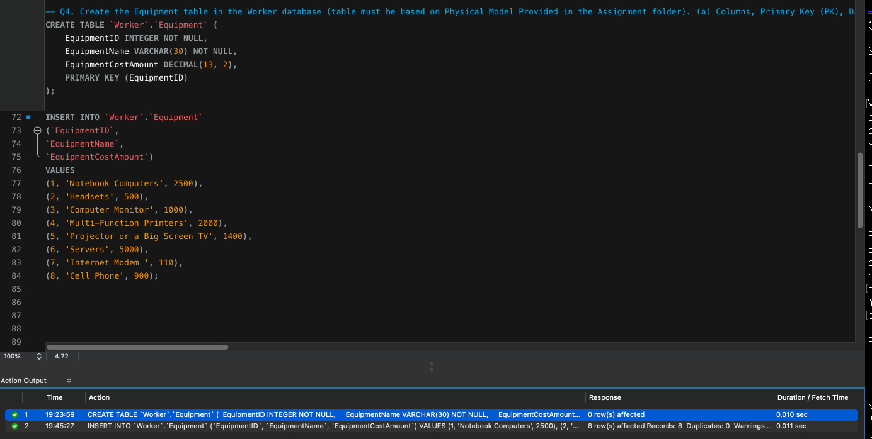

**(d) Retrieve the data from the Equipment table by using the SELECT * statement and order by PK column(s). Show the output. Make sure you show the print screen of the complete set of the rows and columns. The rows must be ordered by PK column(s).**

|  |
| --- |
| SELECT  *  FROM  Worker.Equipment  ORDER BY EquipmentID ASC; |

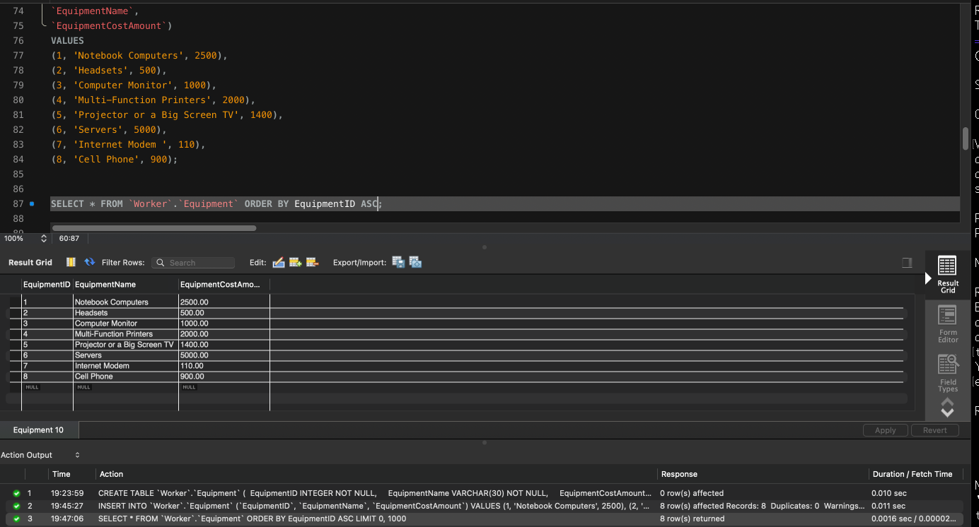

**Q5. Create the EmployeeEquipment table in the Worker database (table must be based on Physical Model Provided in the Assignment folder).**

**(a) Columns, Primary Key (PK), Data Type & length, and NULL/NOT NULL need to be implemented, as provided in the Physical Model.**

|  |  |
| --- | --- |
|  | CREATE TABLE Worker.EmployeeEquipment (  EmployeeID INTEGER NOT NULL,  EquipmentID INTEGER NOT NULL,  FOREIGN KEY (EmployeeID)  REFERENCES Employee (EmployeeID)  ON DELETE CASCADE,  FOREIGN KEY (EquipmentID)  REFERENCES Equipment (EquipmentID)  ON DELETE CASCADE,  PRIMARY KEY (EmployeeID , EquipmentID)  ); |

**(b) Show the table definition (DDL) that you implemented.**

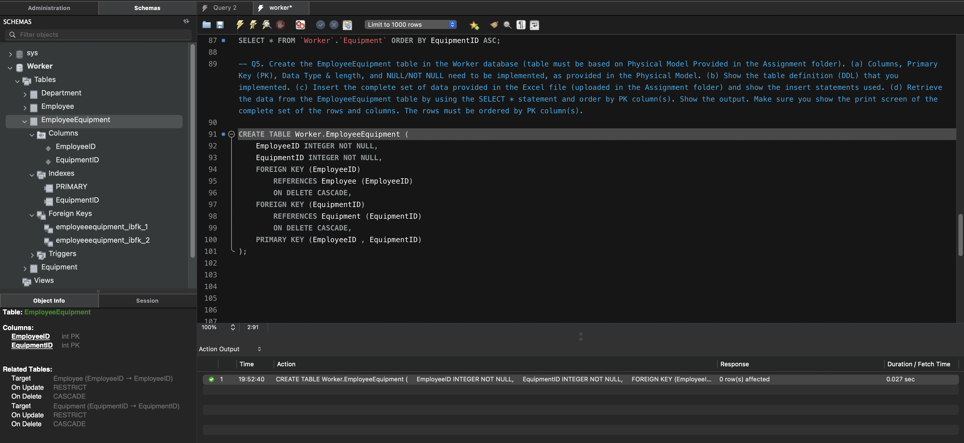

**(c) Insert the complete set of data provided in the Excel file (uploaded in the Assignment folder) and show the insert statements used.**

|  |
| --- |
| **INSERT INTO Worker.EmployeeEquipment(EmployeeID, EquipmentID)**  **VALUES**  **(1,1),**  **(2,1),**  **(2,3),**  **(3,1),**  **(3,2),**  **(3,3),**  **(4,1),**  **(4,2),**  **(5,1),**  **(5,2),**  **(5,3),**  **(6,1),**  **(6,3);** |

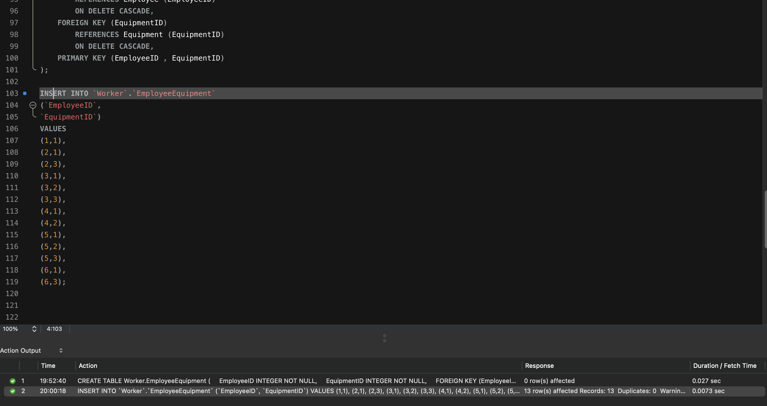

**(d) Retrieve the data from the EmployeeEquipment table by using the SELECT * statement and order by PK column(s). Show the output. Make sure you show the print screen of the complete set of the rows and columns. The rows must be ordered by PK column(s).**

|  |
| --- |
| SELECT  *  FROM  Worker.EmployeeEquipment  ORDER BY EmployeeID , EquipmentID ASC; |

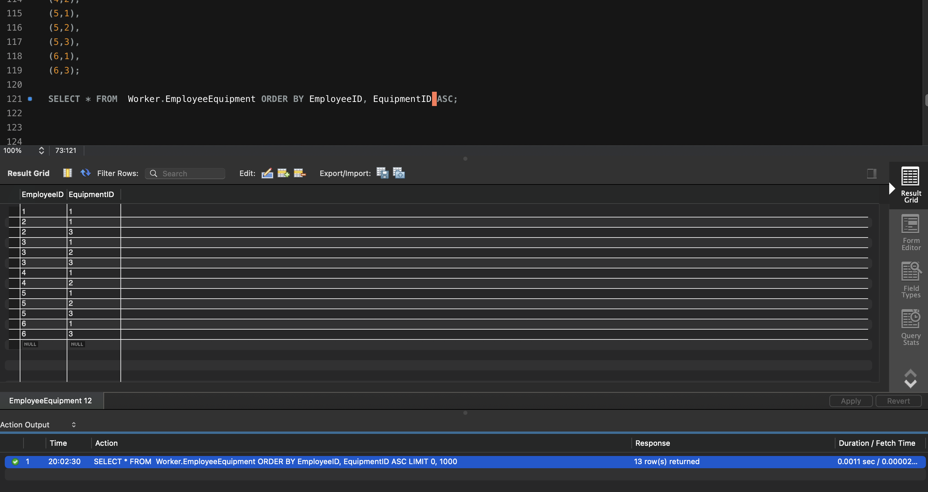

Q6. Create the Training table in the Worker database (table must be based on Physical Model Provided in the Assignment folder).

(a) Columns, Primary Key (PK), Data Type & length, and NULL/NOT NULL need to be implemented, as provided in the Physical Model.

|  |  |
| --- | --- |
|  | CREATE TABLE Worker.Training(  TrainingID INTEGER NOT NULL,  TrainingName VARCHAR(50) NOT NULL,  PRIMARY KEY(TrainingID)  ); |

(b) Show the table definition (DDL) that you implemented.

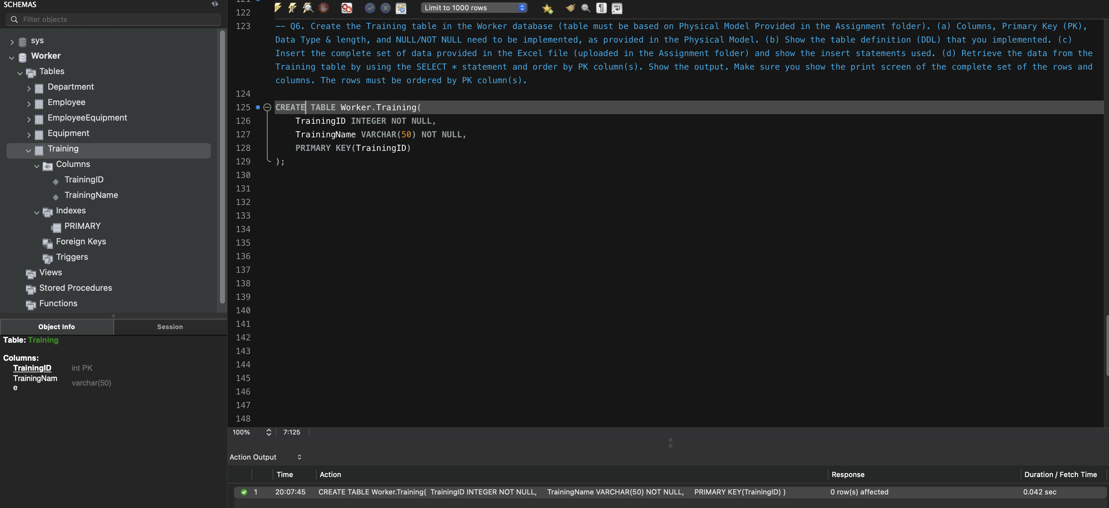

(c) Insert the complete set of data provided in the Excel file (uploaded in the Assignment folder) and show the insert statements used.

|  |
| --- |
| INSERT INTO Worker.Training(TrainingID, TrainingName)  VALUES  (1, 'COVID-19 Awareness and Protection Training'),  (2, 'Code of Conduct Training'),  (3, 'Safety Traning'),  (4, 'Intro to Python'),  (5, 'Machine Learning'),  (6, 'Microsoft Certifications'),  (7, 'Security and Privacy'),  (8, 'Product Knowledge'),  (9, 'Sales Skills'),  (10, 'Employee Relations'),  (11, 'Travel and Expense Management'); |

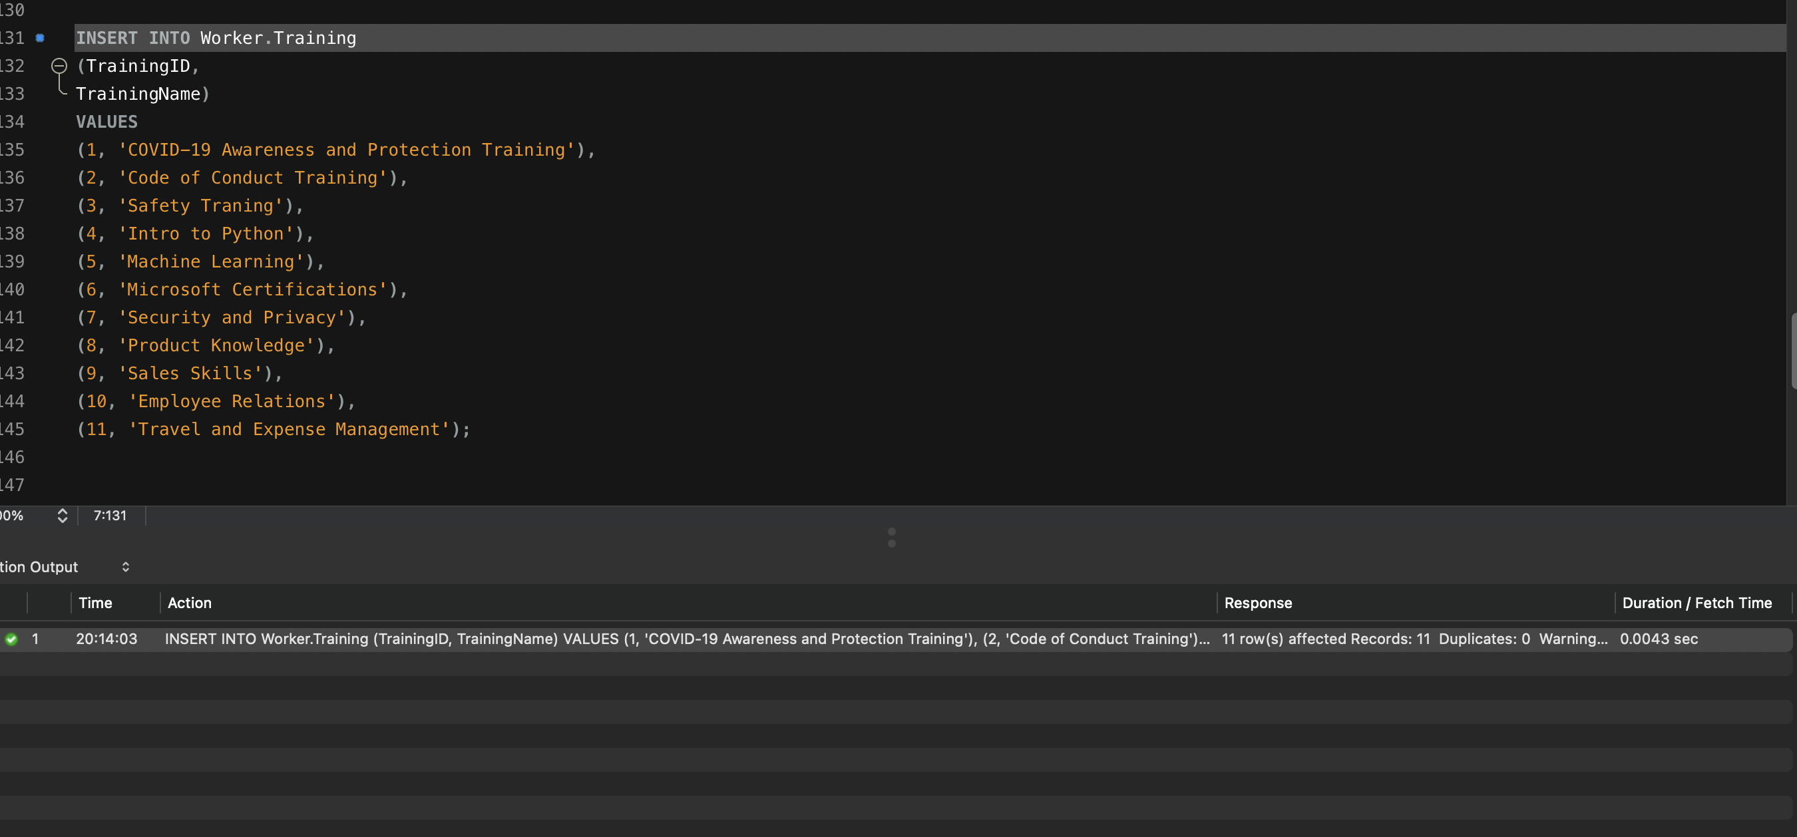

(d) Retrieve the data from the Training table by using the SELECT * statement and order by PK column(s). Show the output. Make sure you show the print screen of the complete set of the rows and columns. The rows must be ordered by PK column(s).

|  |
| --- |
| SELECT  *  FROM  Worker.Training  ORDER BY TrainingID ASC; |

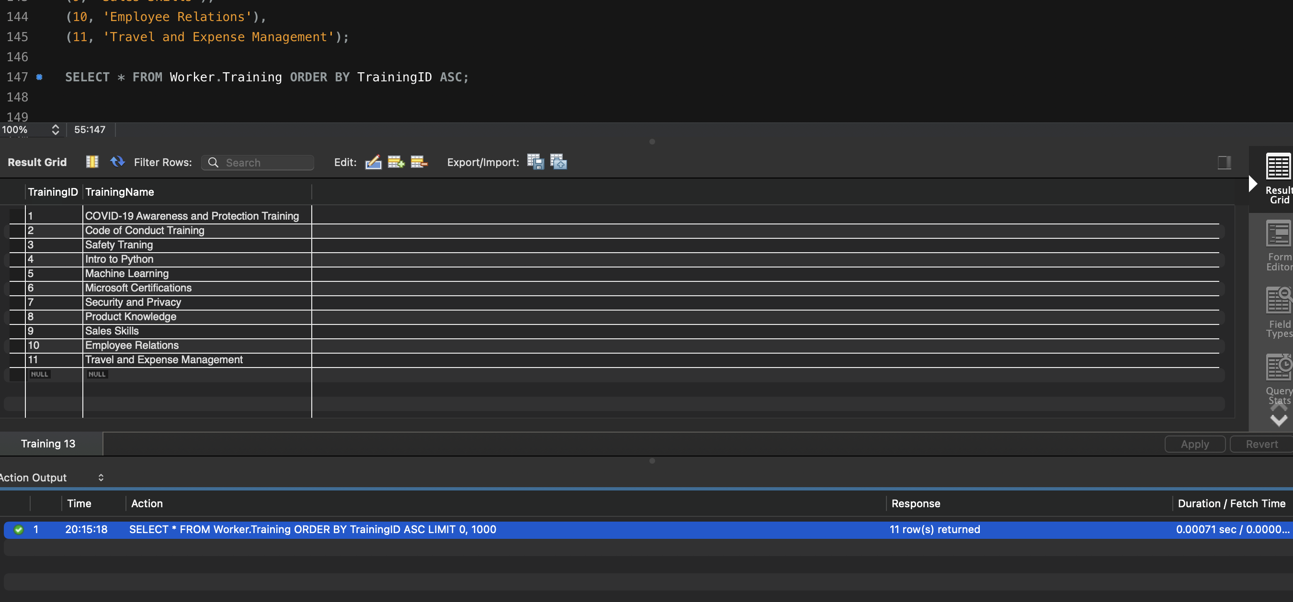

**Q7. Create the EmployeeTraining table in the Worker database (table must be based on Physical Model Provided in the Assignment folder).**

**(a) Columns, Primary Key (PK), Data Type & length, and NULL/NOT NULL need to be implemented, as provided in the Physical Model.**

|  |  |
| --- | --- |
|  | CREATE TABLE Worker.EmployeeTraining (  EmployeeID INTEGER NOT NULL,  TrainingID INTEGER NOT NULL,  FOREIGN KEY (EmployeeID)  REFERENCES Employee (EmployeeID)  ON DELETE CASCADE,  FOREIGN KEY (TrainingID)  REFERENCES Training (TrainingID)  ON DELETE CASCADE,  PRIMARY KEY (EmployeeID , TrainingID)  ); |

**(b) Show the table definition (DDL) that you implemented.**

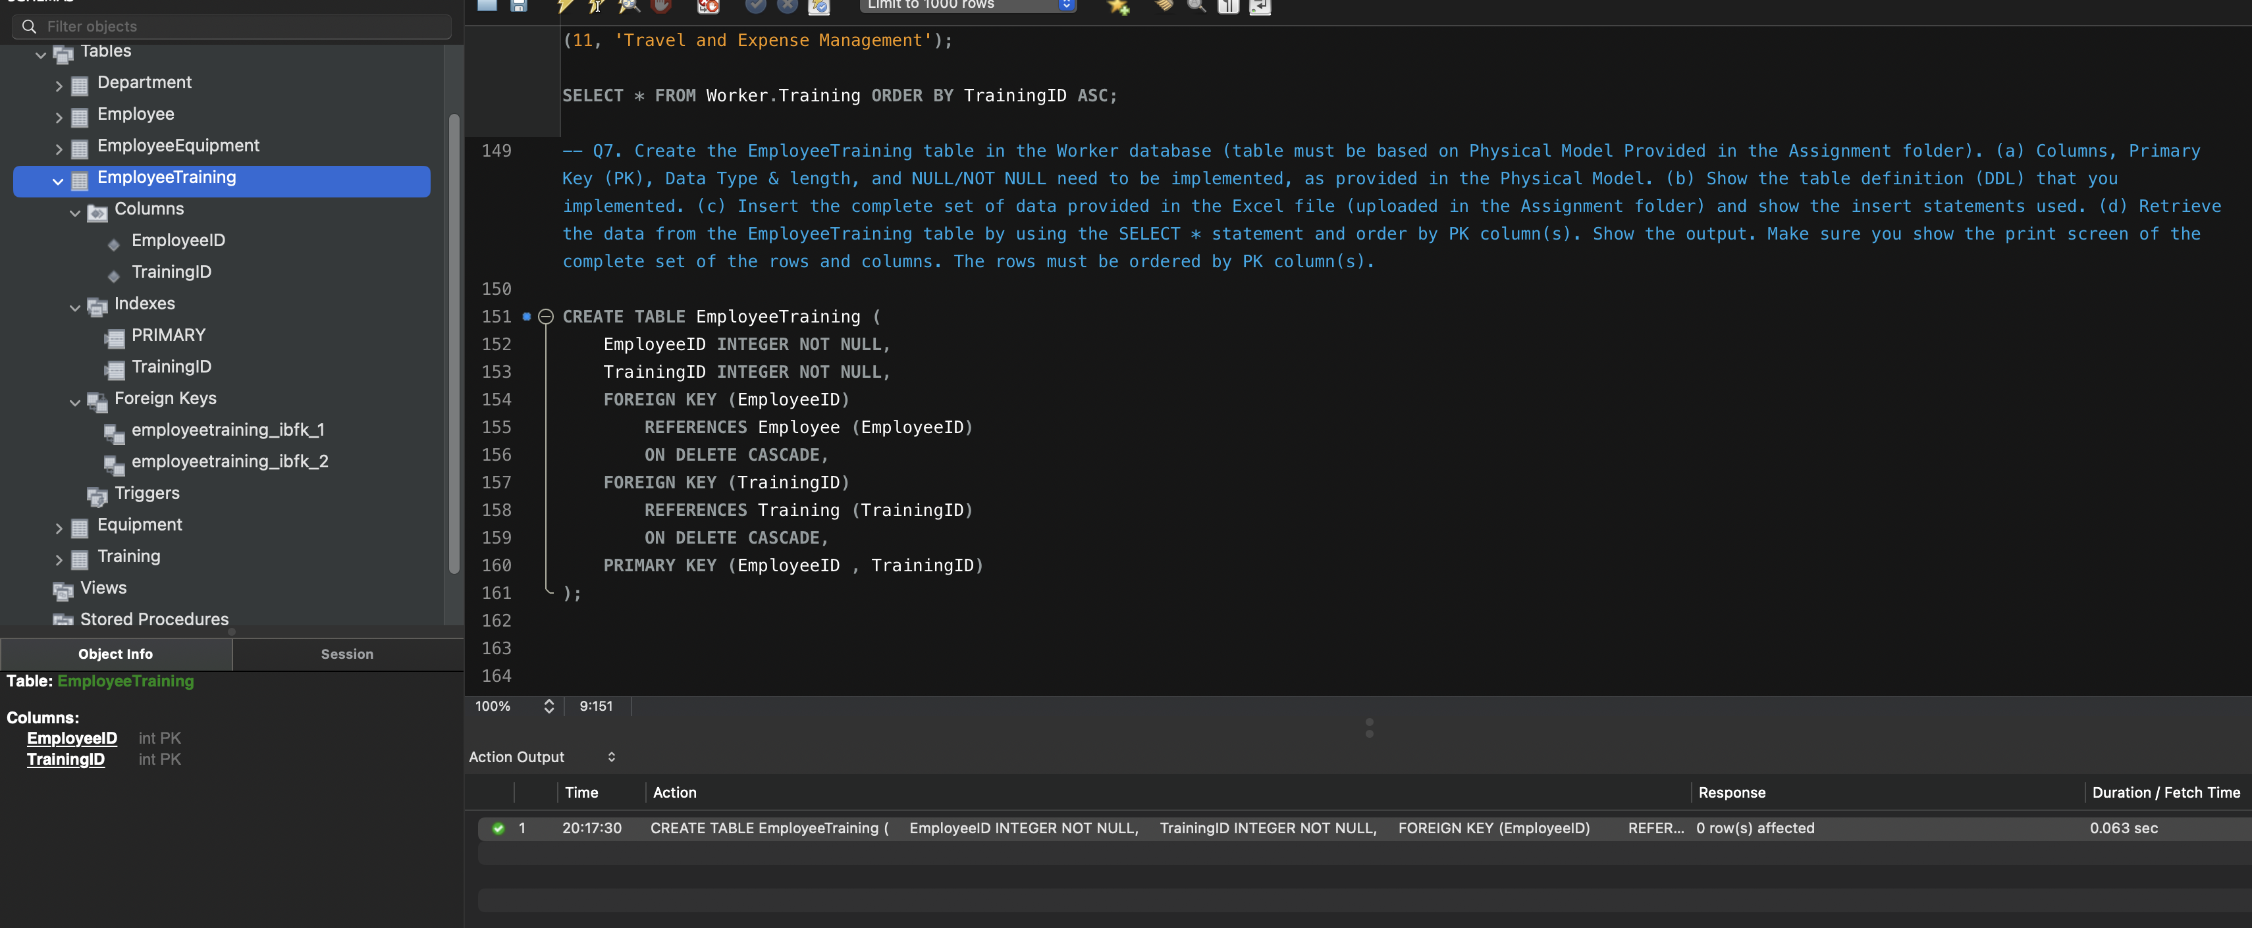

**(c) Insert the complete set of data provided in the Excel file (uploaded in the Assignment folder) and show the insert statements used.**

|  |
| --- |
| INSERT INTO Worker.EmployeeTraining (EmployeeID , TrainingID)  VALUES  (1,2),  (1,3),  (2,2),  (2,4),  (2,5),  (3,2),  (3,6),  (3,7),  (4,2),  (4,8),  (4,9),  (5,2),  **(5,10),**  **(6,2),**  **(6,11);** |

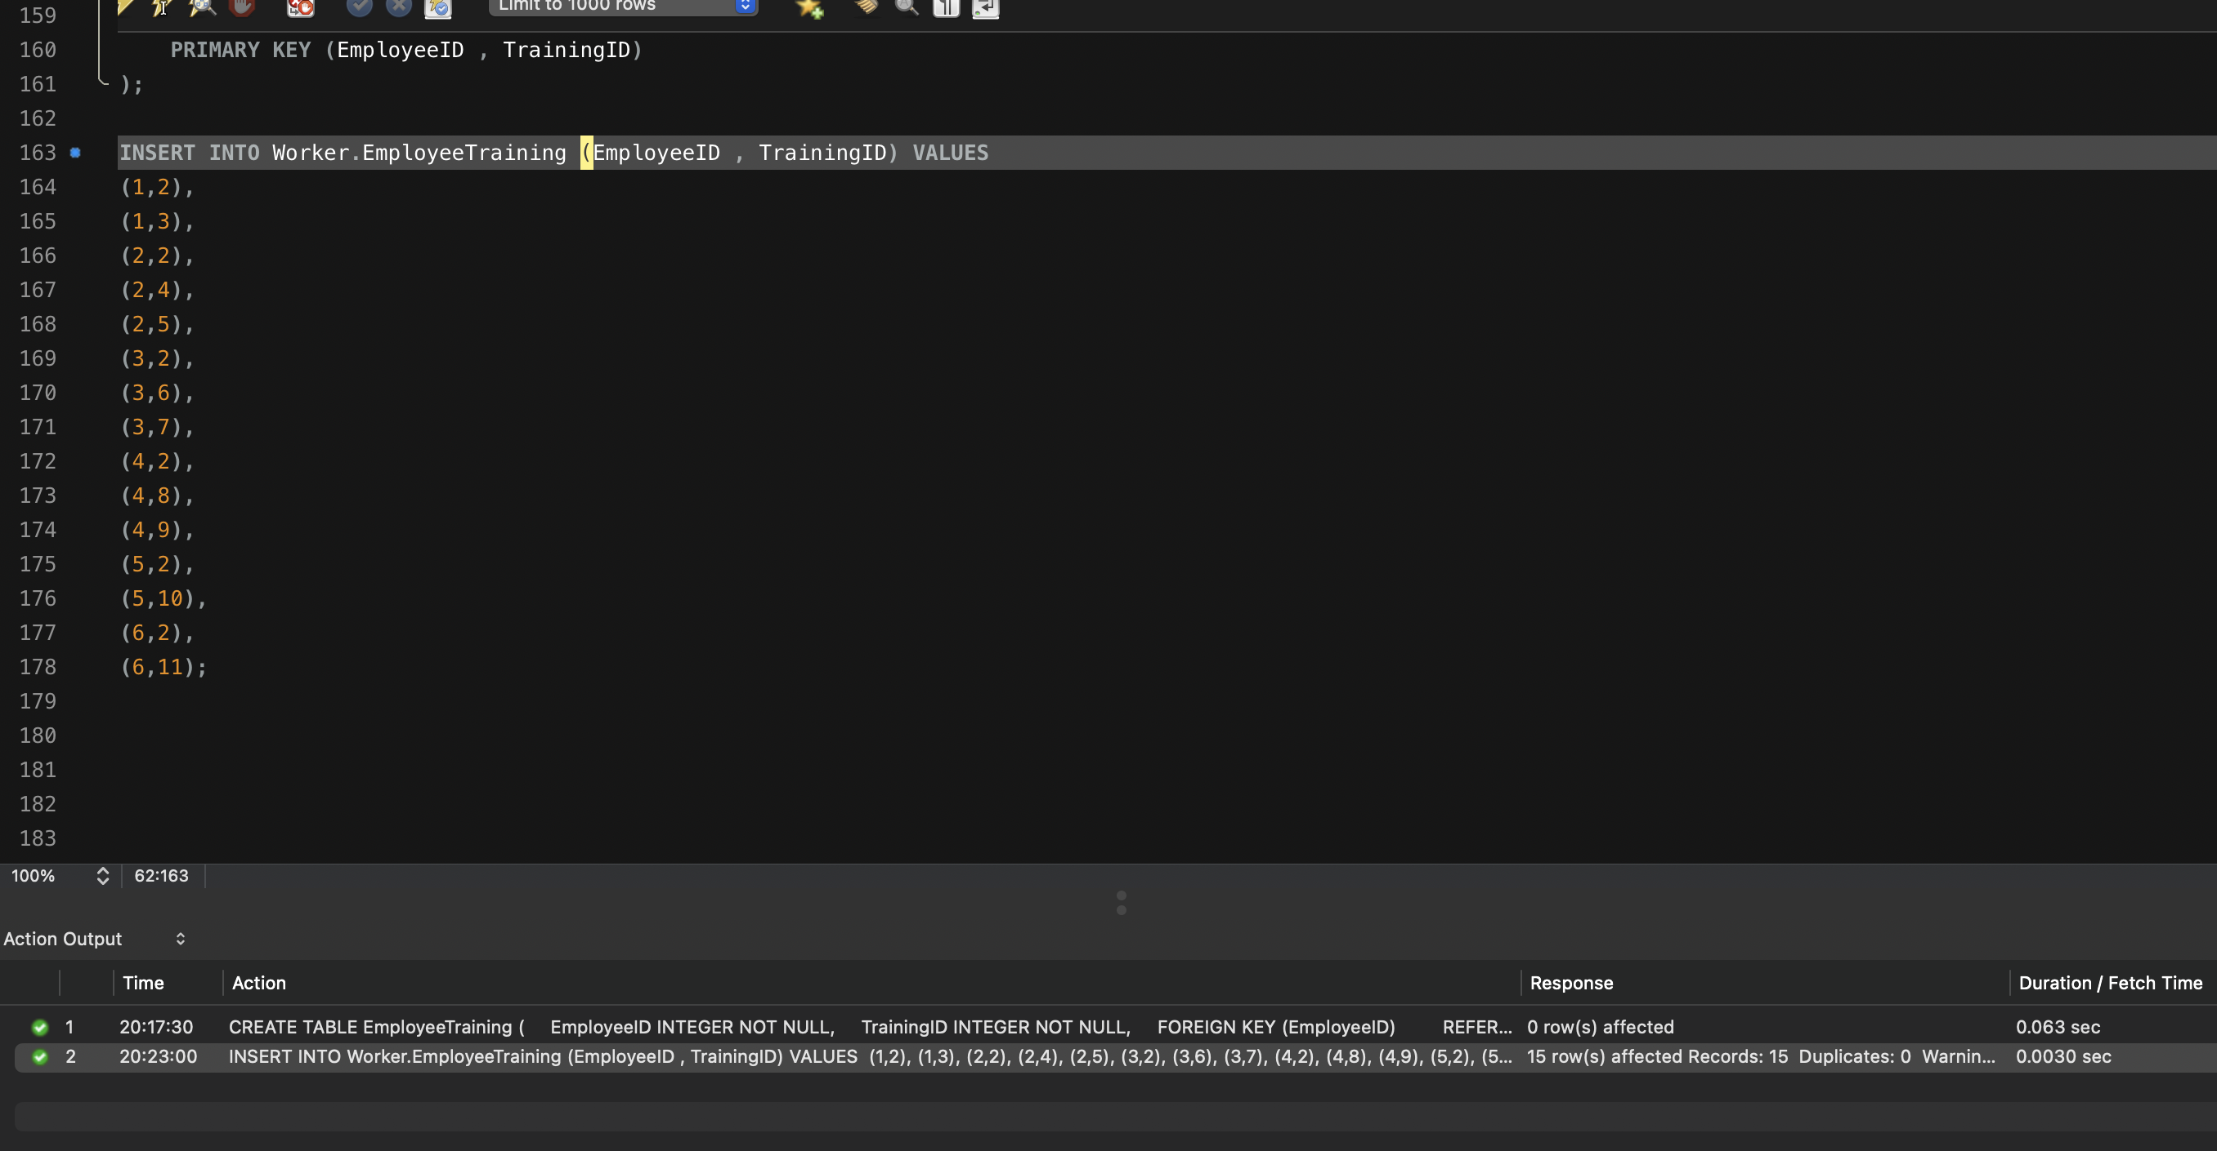

**(d) Retrieve the data from the EmployeeTraining table by using the SELECT * statement and order by PK column(s). Show the output. Make sure you show the print screen of the complete set of the rows and columns. The rows must be ordered by PK column(s).**

|  |
| --- |
| SELECT  *  FROM  Worker.EmployeeTraining  ORDER BY EmployeeID , TrainingID ASC; |

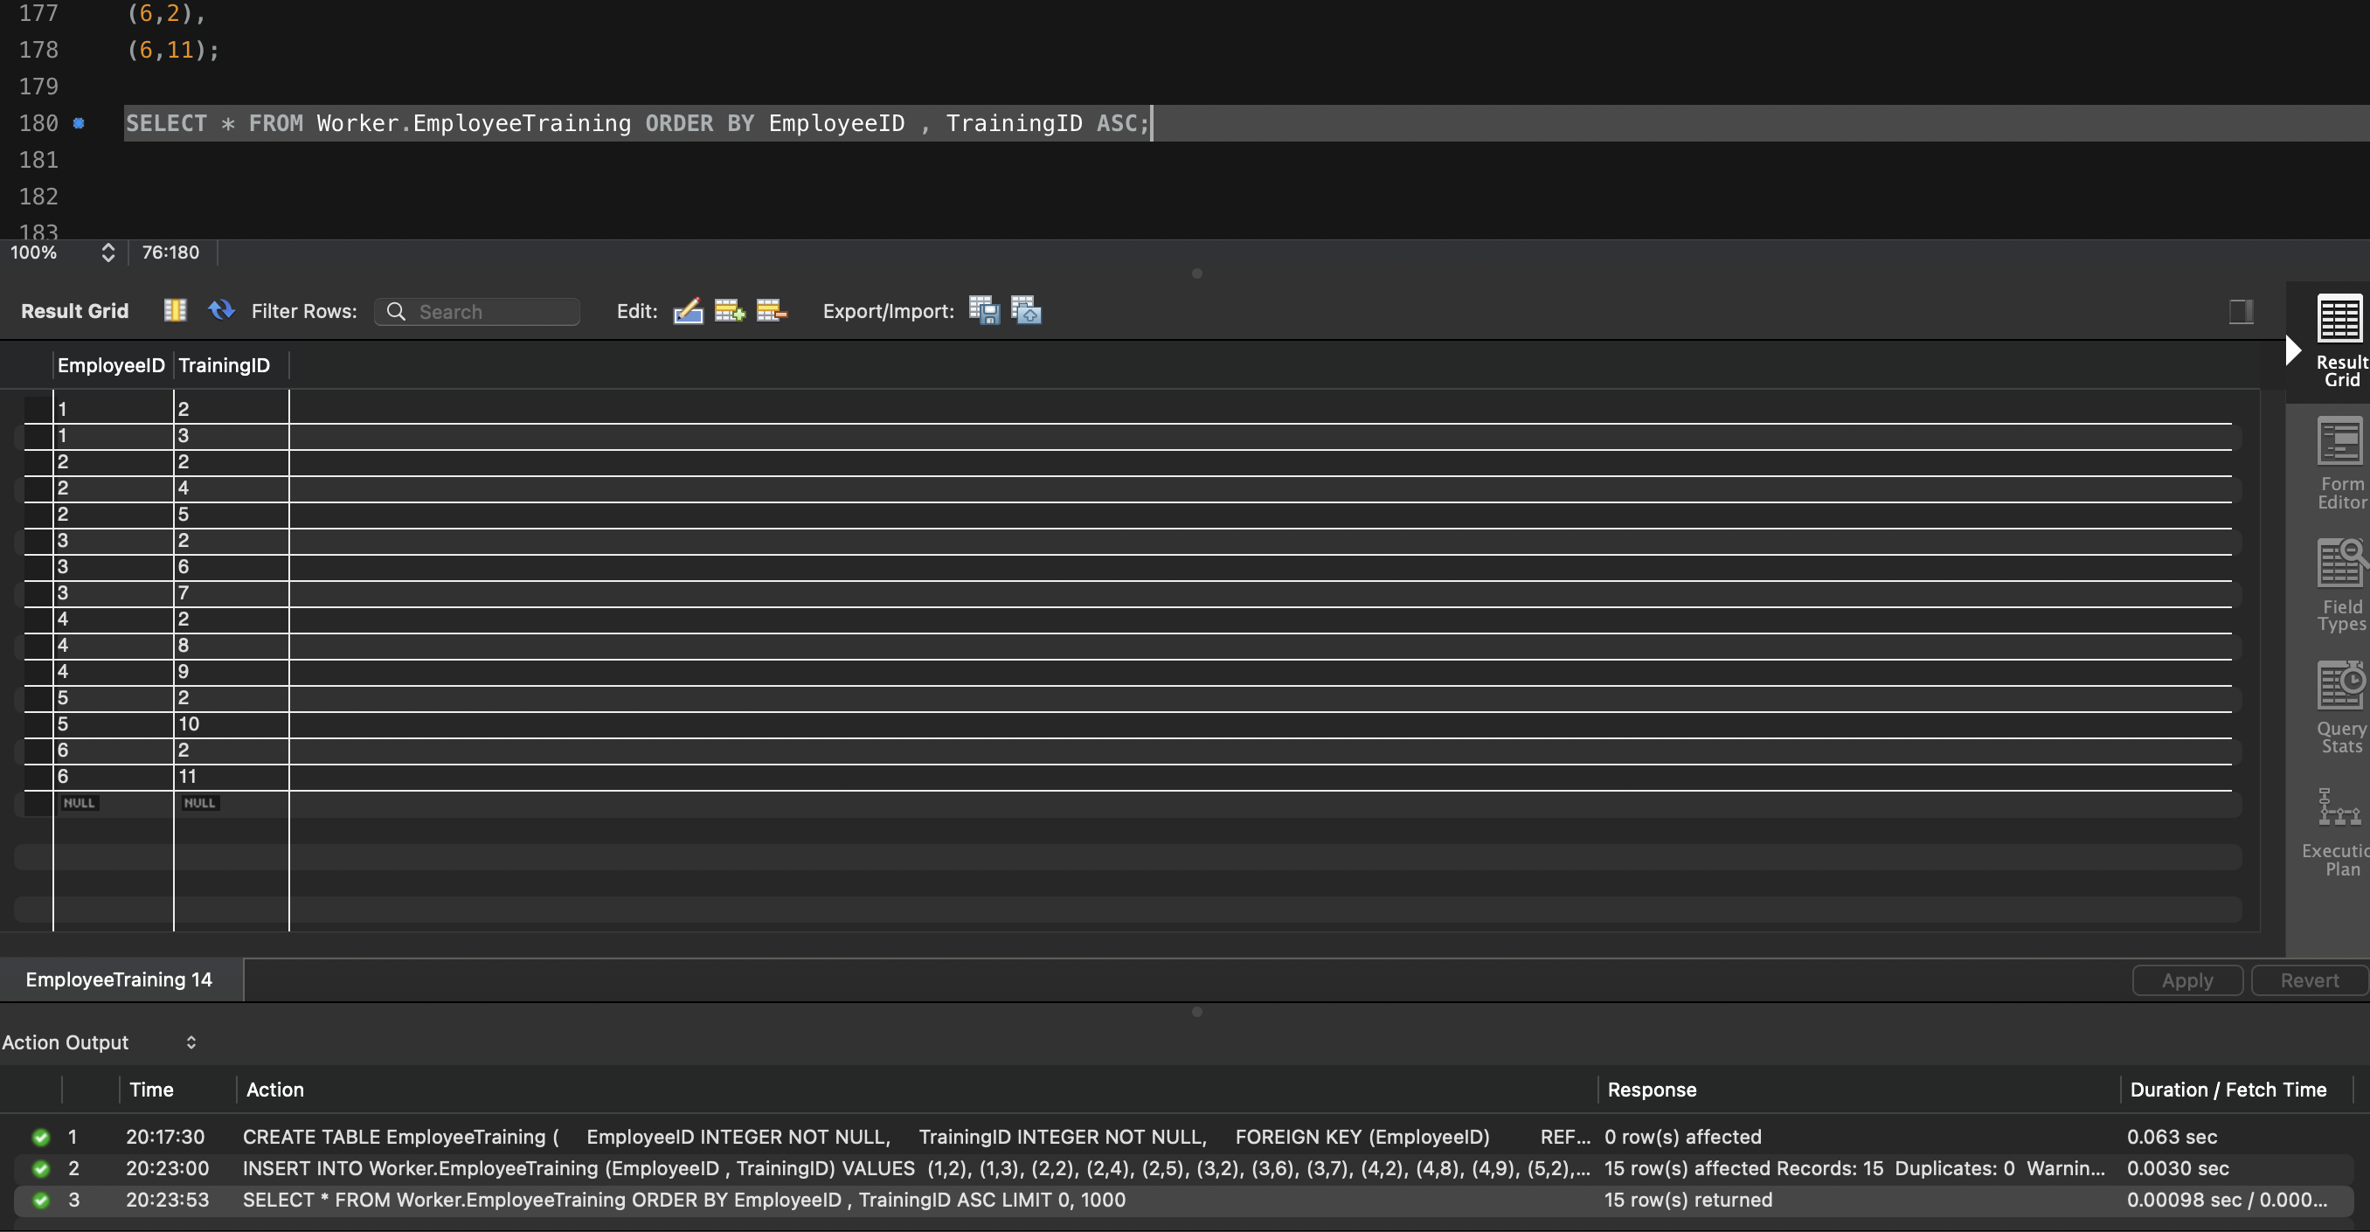

**Q8. Create the Trainer table in the Worker database (table must be based on Physical Model Provided in the Assignment folder).**

**(a) Columns, Primary Key (PK), Data Type & length, and NULL/NOT NULL need to be implemented, as provided in the Physical Model.**

|  |  |
| --- | --- |
|  | CREATE TABLE Trainer (  TrainerID INTEGER NOT NULL,  TrainingID INTEGER NOT NULL,  TrainerFirstName VARCHAR(20) NOT NULL,  TrainerLastName VARCHAR(20) NULL,  FOREIGN KEY (TrainingID)  REFERENCES Training (TrainingID)  ON DELETE CASCADE,  PRIMARY KEY (TrainerID)  ); |

**(b) Show the table definition (DDL) that you implemented.**

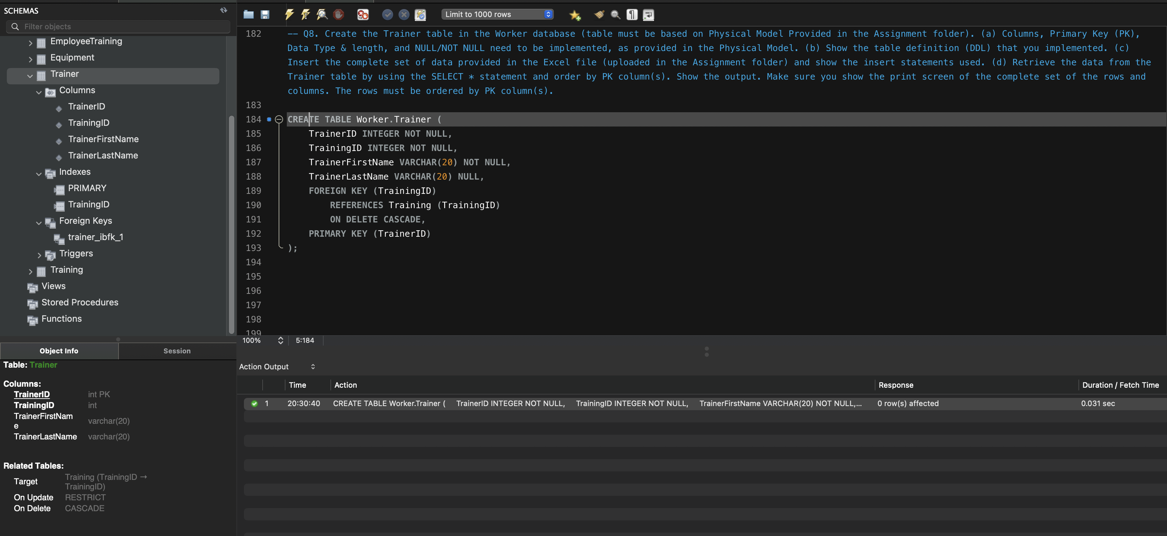

**(c) Insert the complete set of data provided in the Excel file (uploaded in the Assignment folder) and show the insert statements used.**

|  |
| --- |
| **INSERT INTO**  **Worker.Trainer(TrainerID, TrainingID, TrainerFirstName, TrainerLastName)**  **VALUES**  **(1,1, 'James' ,'Smith'),**  **(2,1,'Johnny' ,'Khor'),**  **(3,2, 'Michael','Smith'),**  **(4,3,'Maria','Garcia'),**  **(5,4,'John', NULL),**  **(6,4,'Paul','Deitel'),**  **(7,5,'Mike' ,'Taylor'),**  **(8,5,'Avinash','Navlani'),**  **(9,6,'Robert' ,'Smith'),**  **(10,7,'Maria' ,'Rodriguez'),**  **(11,8,'Mike' ,'Donlon'),**  **(12,9,'Kathy' ,'Corby'),**  **(13,10,'Mary' ,'Garcia'),**  **(14,10,'Vanessa',NULL),**  **(15,11,'Jordan',NULL),**  **(16,11,'Maria' ,'Hernandez');** |

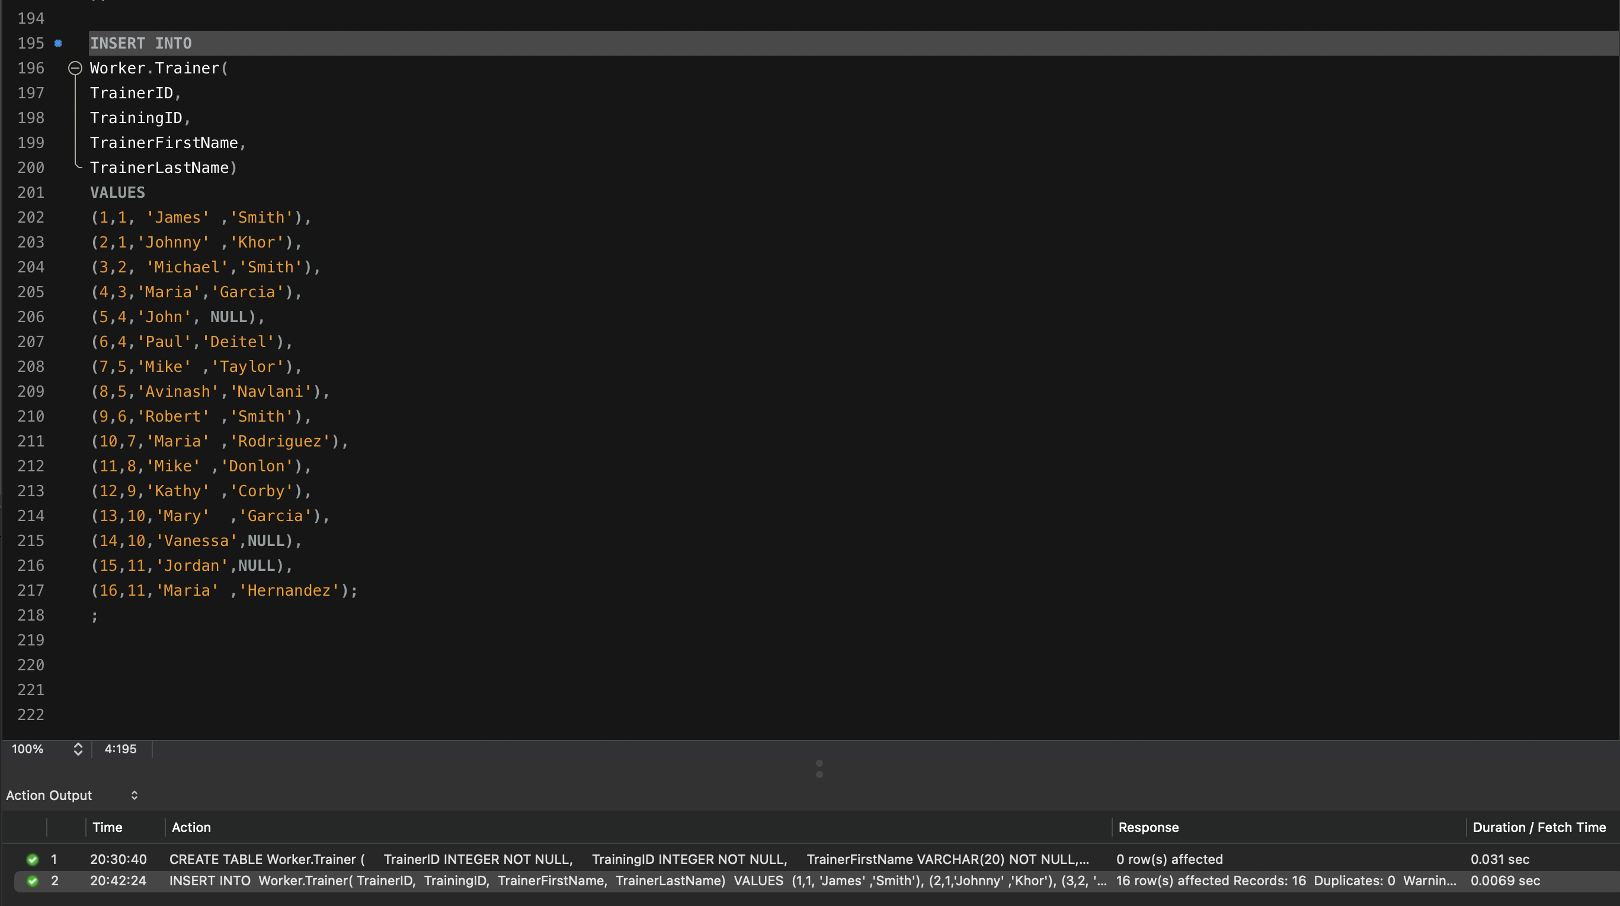

**(d) Retrieve the data from the Trainer table by using the SELECT * statement and order by PK column(s). Show the output. Make sure you show the print screen of the complete set of the rows and columns. The rows must be ordered by PK column(s).**

|  |
| --- |
| **SELECT**  **\***  **FROM**  **Worker.Trainer**  **ORDER BY TrainerID ASC;** |

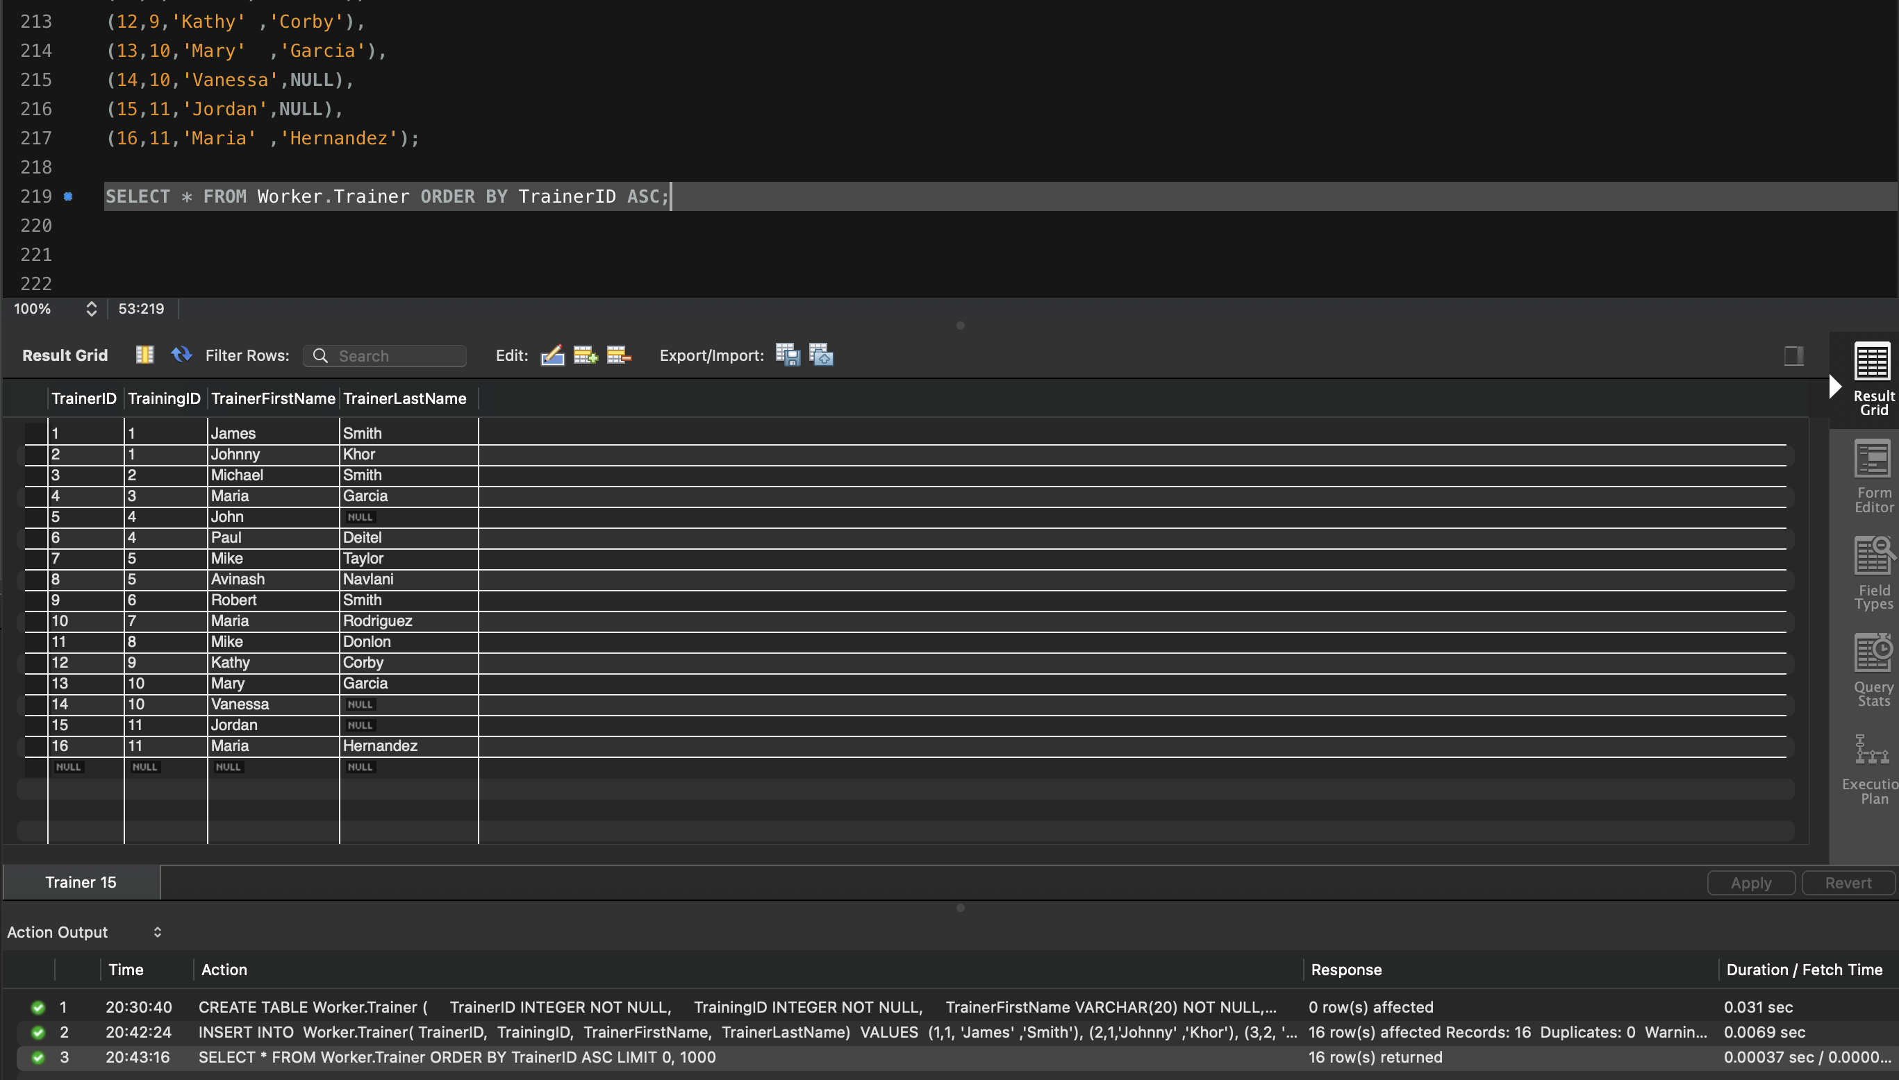

**Q9. Retrieve the data from the Trainer table by using the SELECT * statement with filter, WHERE TrainerLastName IS NULL. Show the output. Make sure you show the print screen of the complete set of the rows and columns. The rows must be ordered by PK column(s).**

|  |
| --- |
| **SELECT**  **\***  **FROM**  **Worker.Trainer**  **WHERE**  **TrainerLastName IS NULL**  **ORDER BY TrainerID ASC;** |

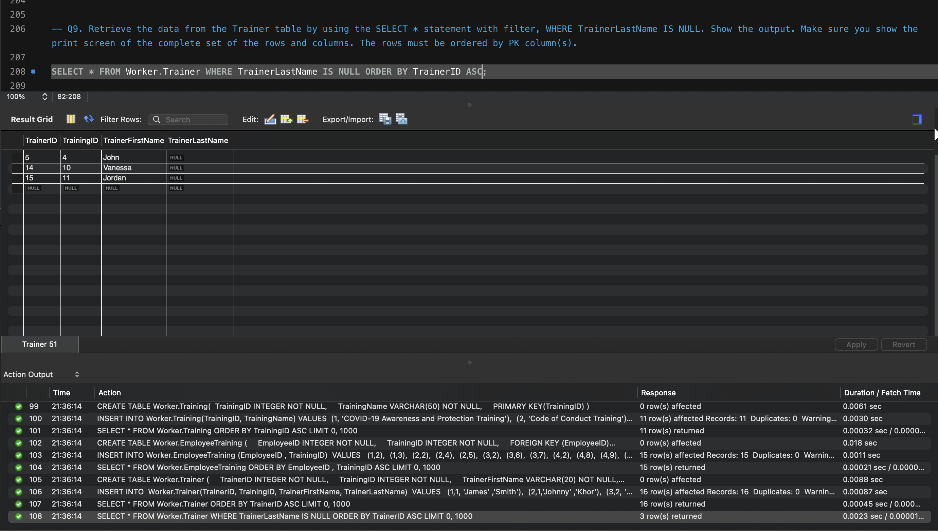

**Q10.** **By using the SHOW tables statements, show the list of tables you have created in the Worker database. Show the screenshot of the execution of the above statements and results. Make sure you show the print screen of the complete set of the rows and columns. The rows must be ordered by PK column(s).**

|  |
| --- |
| **SHOW TABLES IN Worker;** |

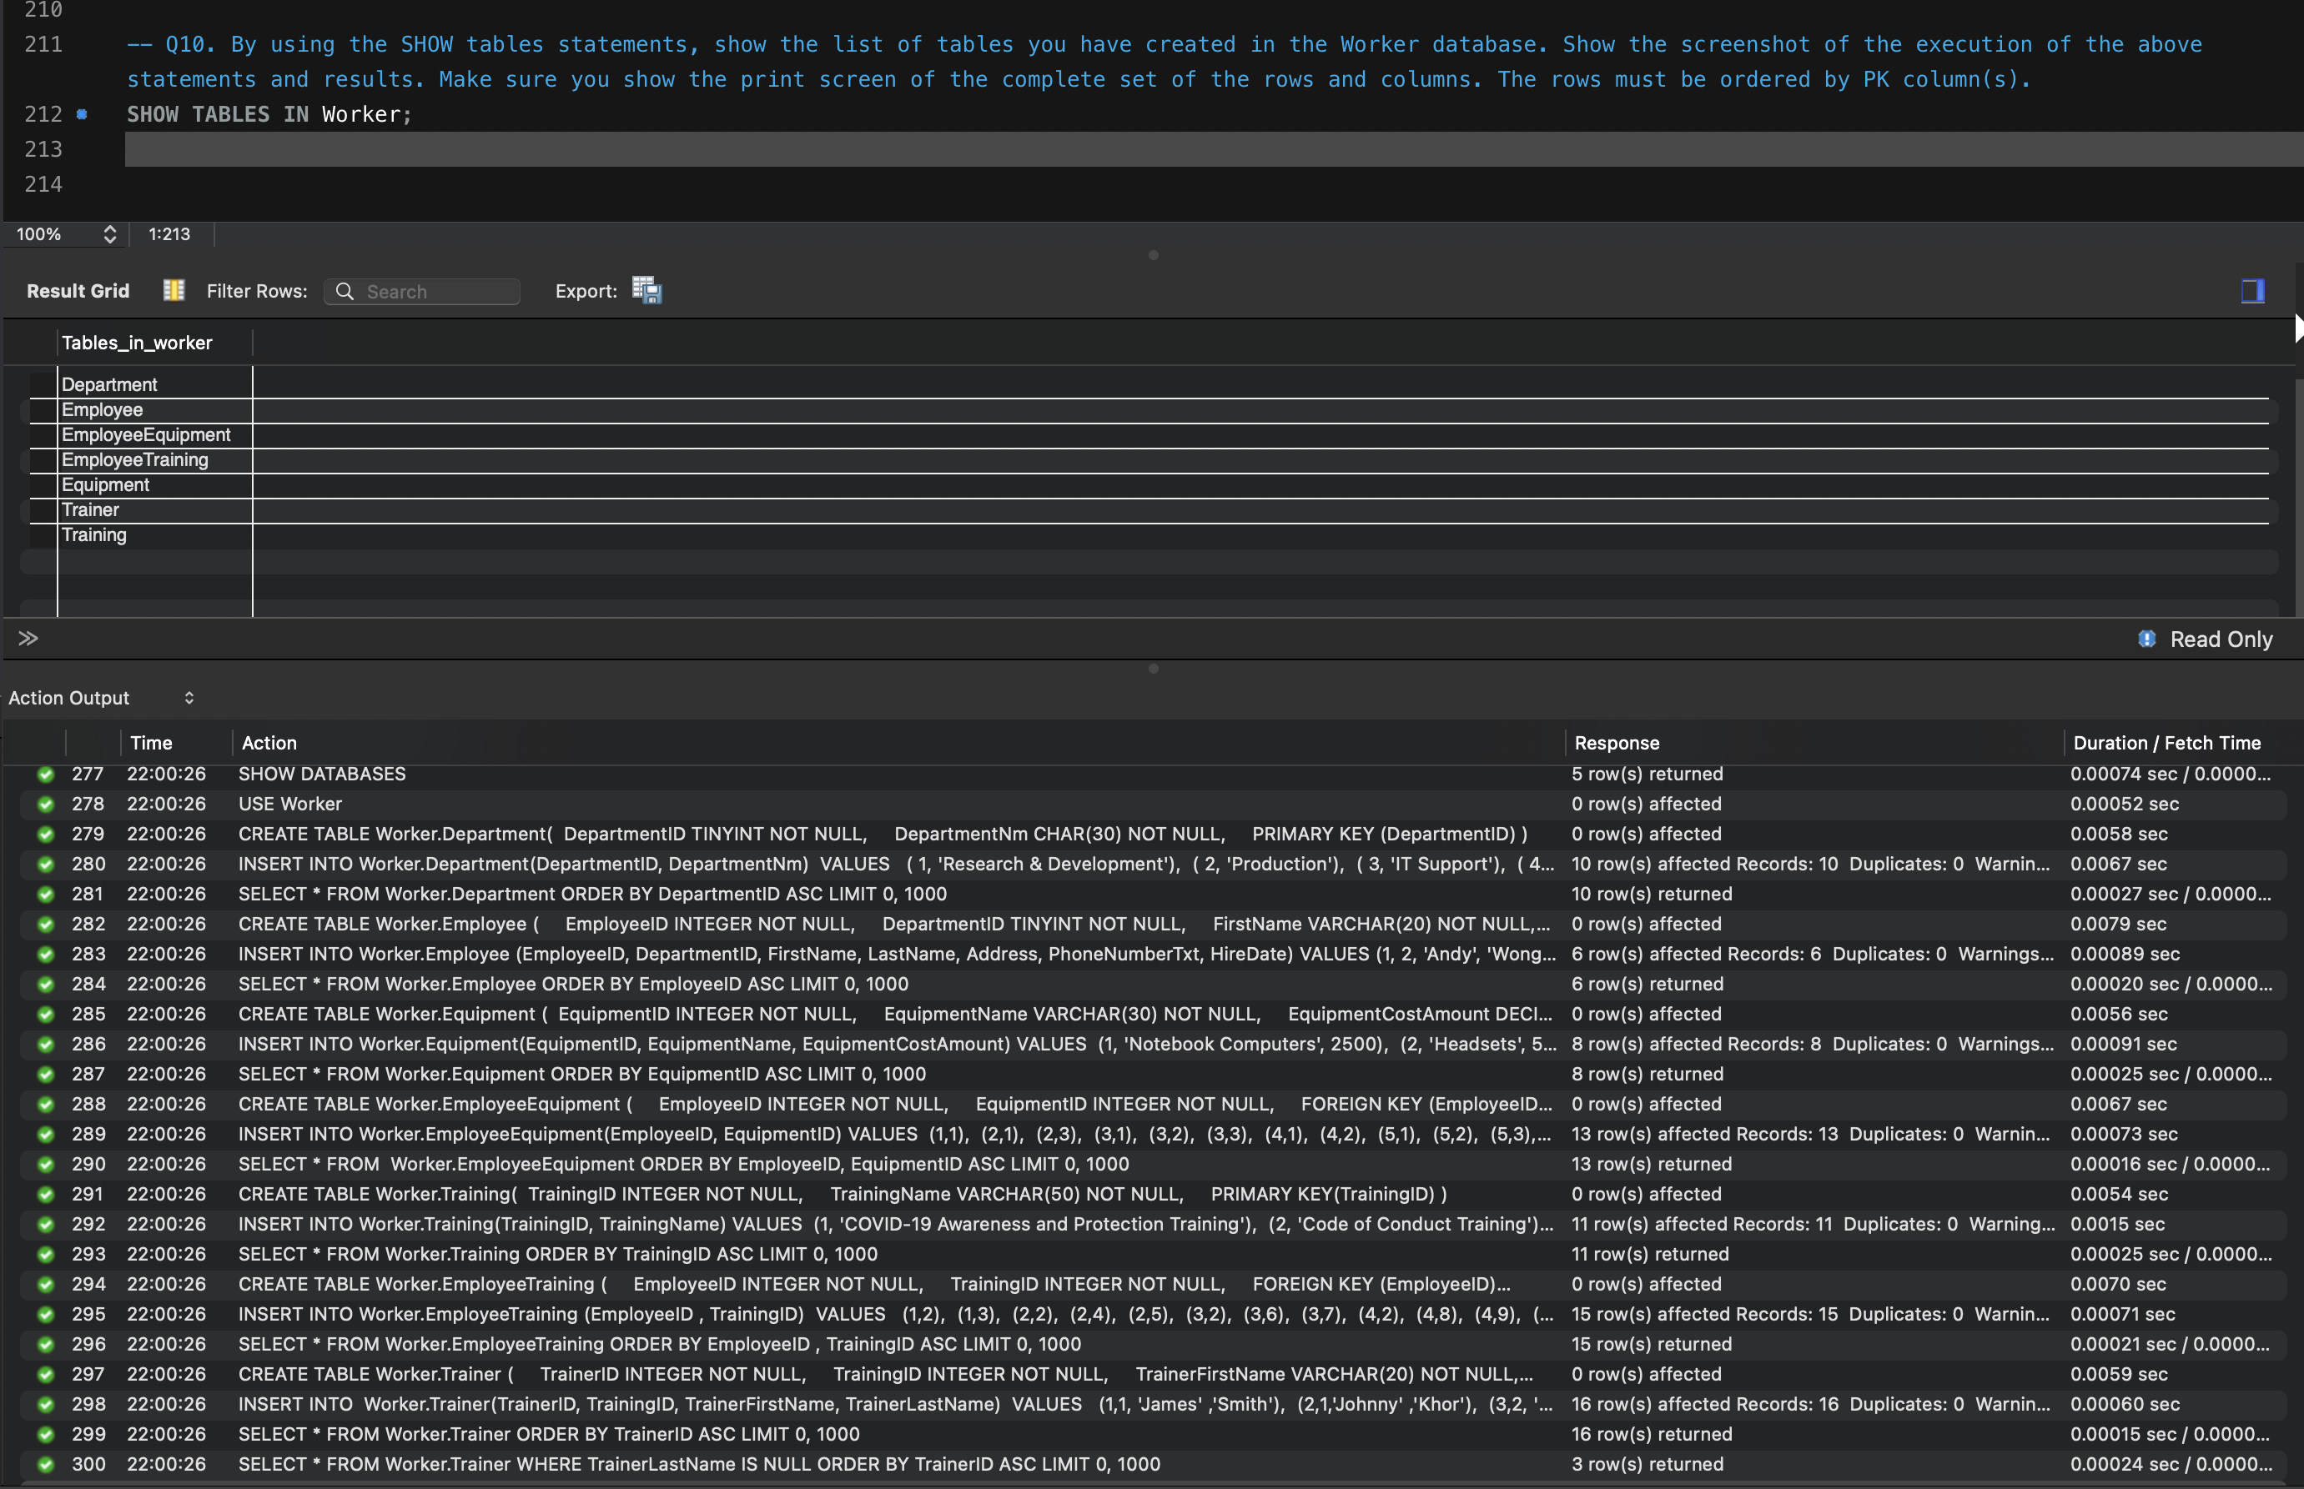

**Q11. Write a single-row subquery to display EmployeeID, FirstName, LastName, and HireDate of employees hired after employee Vivek Pandey. Sort the results by EmployeeID. Make sure you show the print screen of the complete set of the rows, and columns as specified.**

|  |
| --- |
| SELECT  EmployeeID, FirstName, LastName, HireDate  FROM  Worker.Employee  WHERE  HireDate > (SELECT  HireDate  FROM  Worker.Employee  WHERE  FirstName = 'Vivek'  AND LastName = 'Pandey')  ORDER BY EmployeeID ASC; |

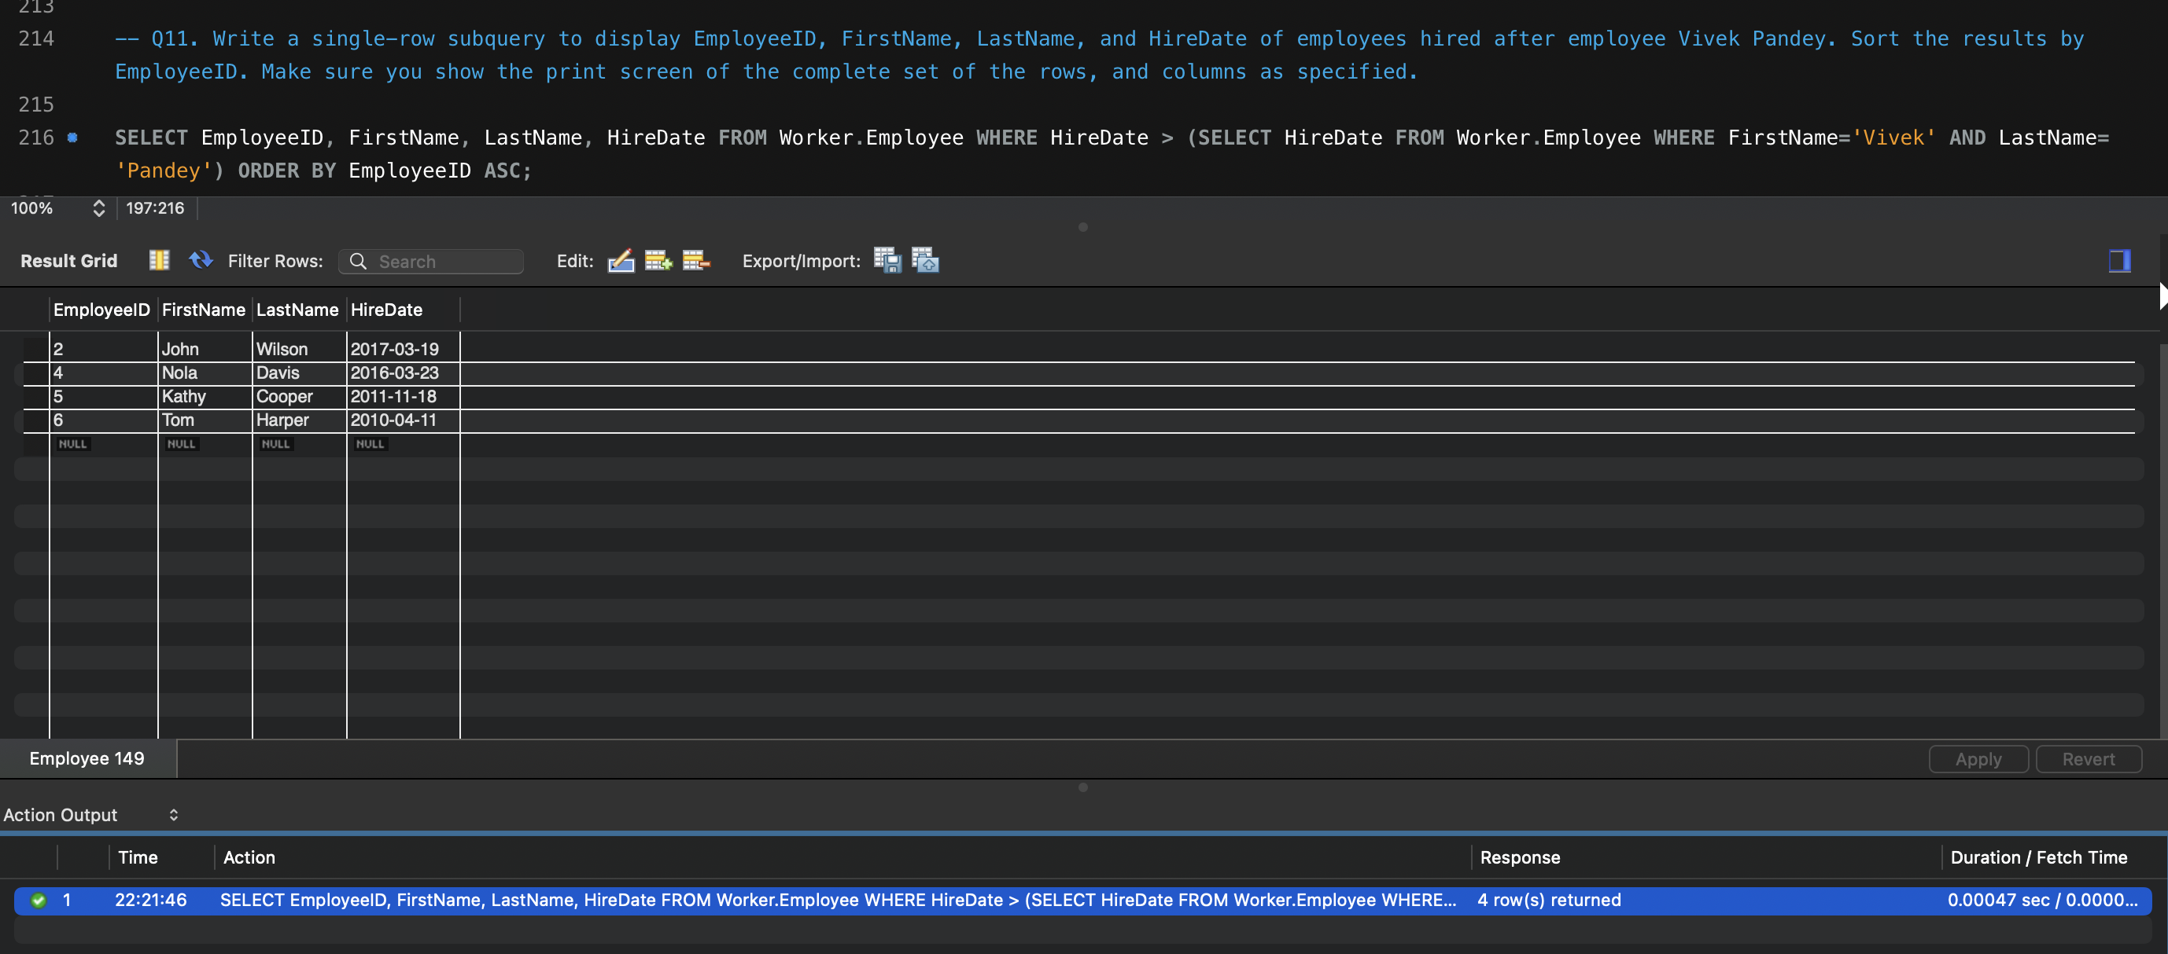

**Q12. Write a query to display FirstName, LastName, and TrainingName for employee Tom Harper. Sort the results by TrainingName. Make sure you show the print screen of the complete set of the rows, and columns as specified.**

|  |
| --- |
| SELECT  e.FirstName, e.LastName, t.TrainingName  FROM  Worker.Employee e  JOIN  Worker.EmployeeTraining et  JOIN  Worker.Training t ON e.EmployeeID = et.EmployeeID  AND et.TrainingID = t.TrainingID  WHERE  e.FirstName = 'Tom'  AND e.LastName = 'Harper'  ORDER BY t.TrainingName ASC; |

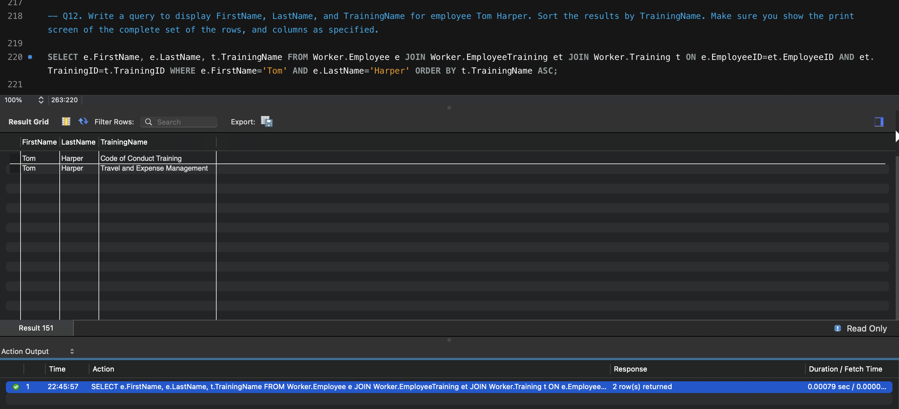

**Q13. Write a query to display the complete list of Trainings, and trainers (first and last name) available for each training. Sort the output by TrainingName and Trainers' first and last name. Make sure you show the print screen of the complete set of the rows, and columns as specified.**

|  |
| --- |
| **SELECT**  t.TrainingName, tnr.TrainerFirstName, tnr.TrainerLastName  FROM  Worker.Training t  JOIN  Worker.Trainer tnr ON t.TrainingID = tnr.TrainingID  ORDER BY t.TrainingName , tnr.TrainerFirstName , tnr.TrainerLastName ASC; |

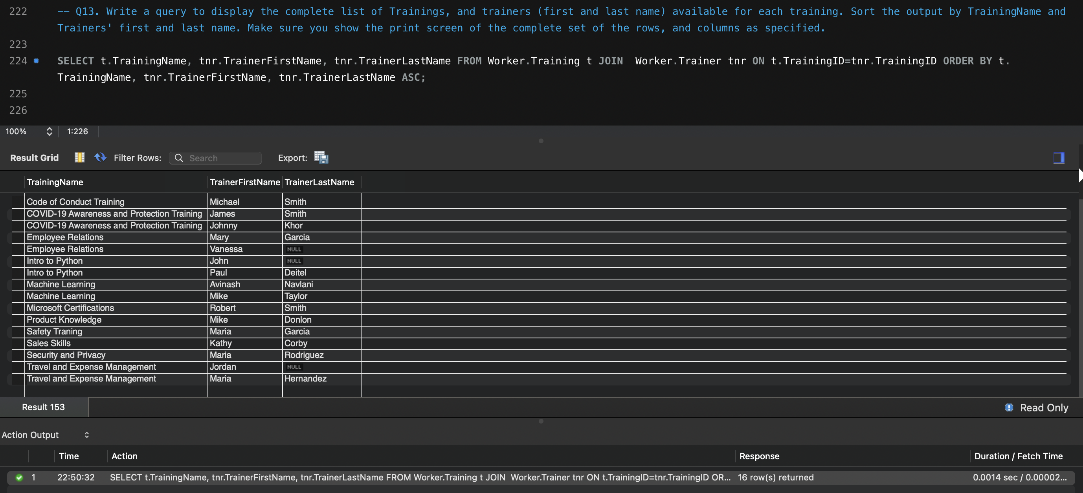

**Q14. Write a multiple-row subquery to display EmployeeID, FirstName, LastName, and HireDate of employees who work for the following departments: Accounting and Finance, IT Support, and Production. Sort the results by EmployeeID. Make sure you show the print screen of the complete set of the rows, and columns as specified.**

|  |
| --- |
| SELECT  EmployeeID, FirstName, LastName, HireDate  FROM  Worker.Employee  WHERE  DepartmentID IN (SELECT  DepartmentID  FROM  Worker.Department  WHERE  DepartmentNm IN ('Accounting and Finance' , 'IT Support', 'Production'))  ORDER BY EmployeeID ASC; |

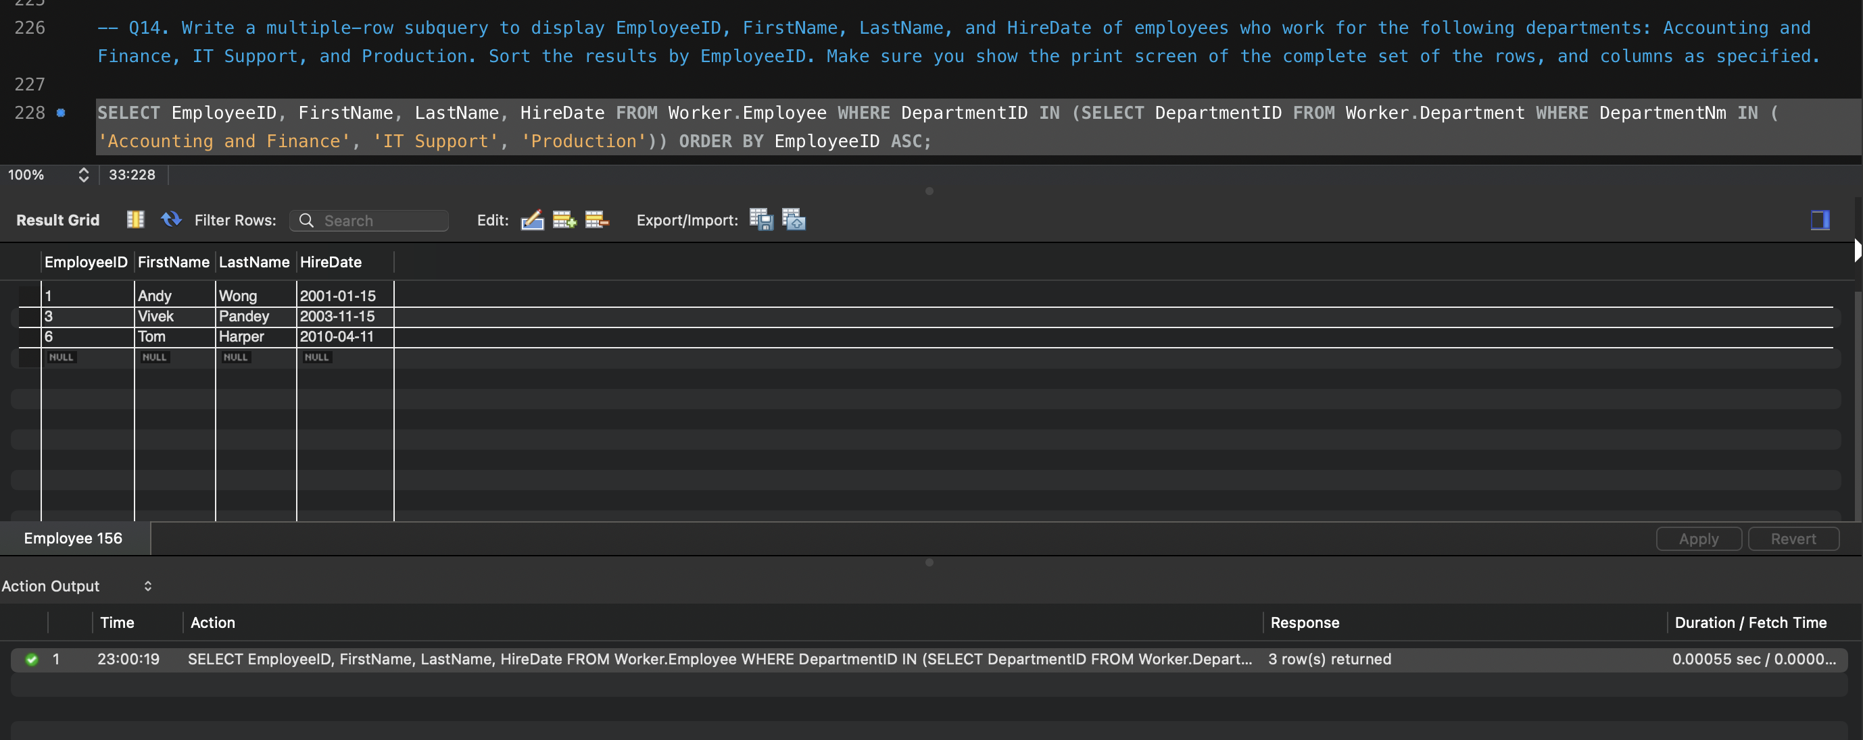

**Q15. Write a query to display the EmployeeID, FirstName, LastName, EquipmentName, and EquipmentCostAmount for one of the employees. Sort the results by EmployeeID. Make sure you show the print screen of the complete set of the rows, and columns as specified.**

**CASE1: ALL EMPLOYEES**

|  |
| --- |
| SELECT  e.EmployeeID,  e.FirstName,  e.LastName,  eq.EquipmentName,  eq.EquipmentCostAmount  FROM  Worker.Employee e  JOIN  Worker.EmployeeEquipment ee  JOIN  Worker.Equipment eq ON e.EmployeeID = ee.EmployeeID  AND ee.EquipmentID = eq.EquipmentID  ORDER BY e.EmployeeID ASC; |

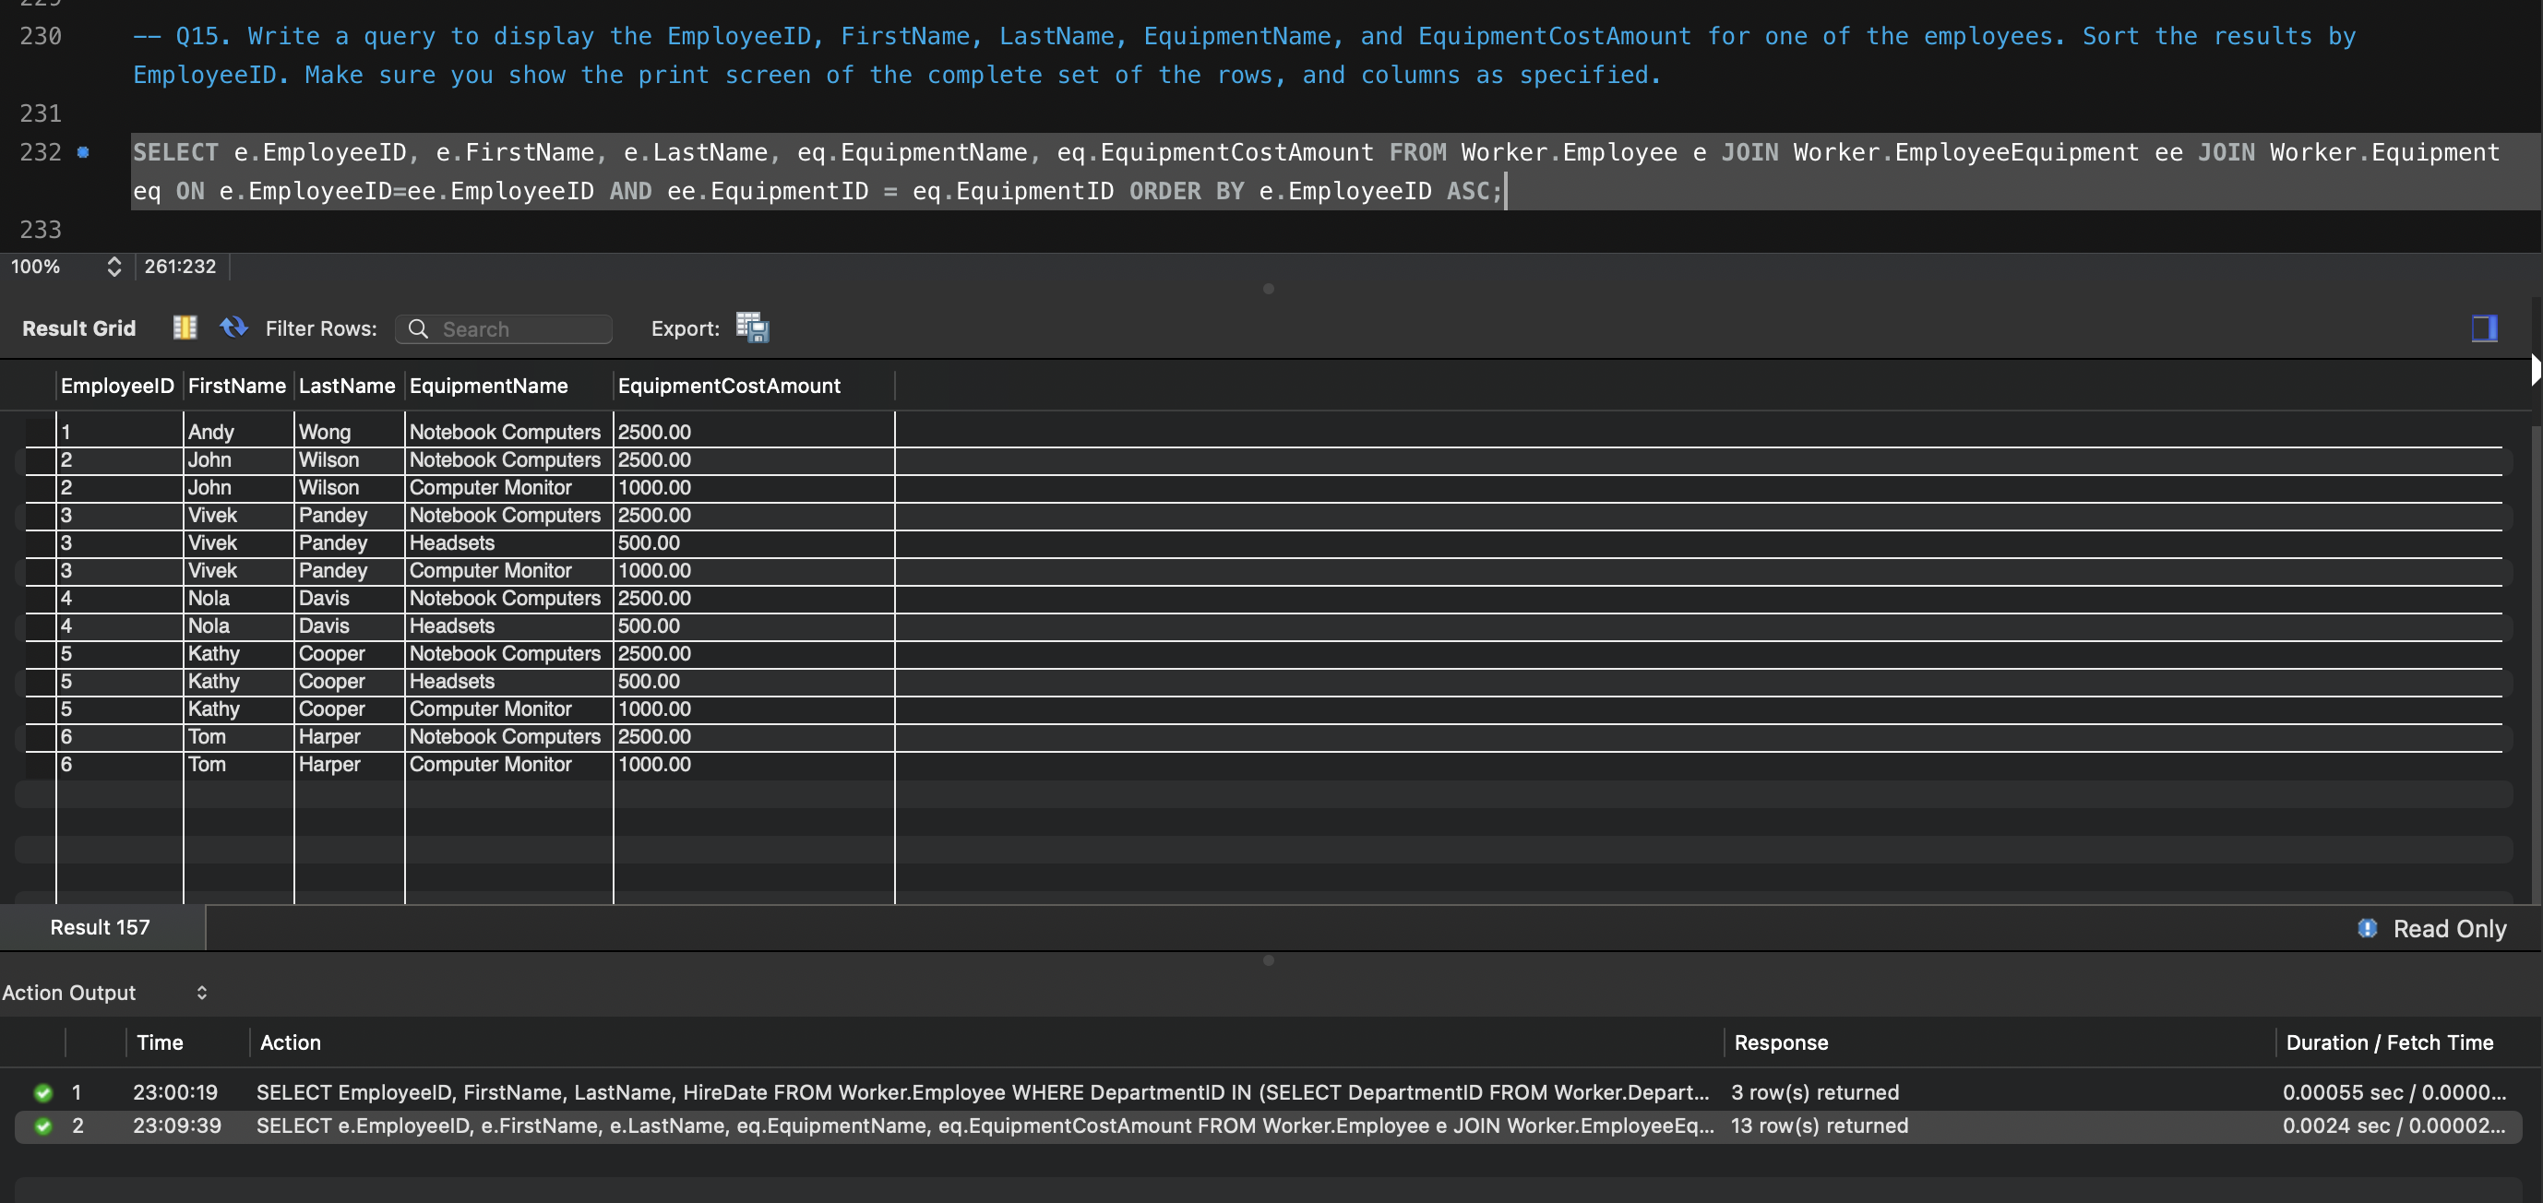

**CASE2: The below case is where we filtered by one Employee (here I choose EmployeeID=3)**

|  |
| --- |
| SELECT  e.EmployeeID,  e.FirstName,  e.LastName,  eq.EquipmentName,  eq.EquipmentCostAmount  FROM  Worker.Employee e  JOIN  Worker.EmployeeEquipment ee  JOIN  Worker.Equipment eq ON e.EmployeeID = ee.EmployeeID  AND ee.EquipmentID = eq.EquipmentID  WHERE  e.EmployeeID = 3  ORDER BY e.EmployeeID ASC; |

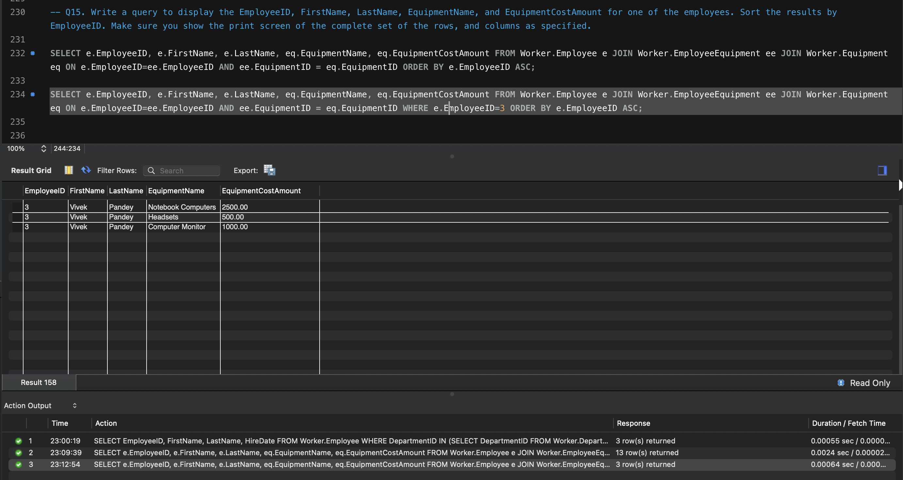

**Q16. Write a query to display the TrainingID, TrainingName, TrainerID, TrainerFirstName, and TrainerLastName with the trainers who did not provide their last name. Sort the results by TrainingID and TrainerID. Make sure you show the print screen of the complete set of the rows, and columns as specified.**

|  |
| --- |
| SELECT  t.TrainingID,  t.TrainingName,  tr.TrainerID,  tr.TrainerFirstName,  tr.TrainerLastName  FROM  Worker.Training t  JOIN  Worker.Trainer tr ON t.TrainingID = tr.TrainingID  WHERE  tr.TrainerLastName IS NULL  ORDER BY TrainingID , TrainerID ASC; |

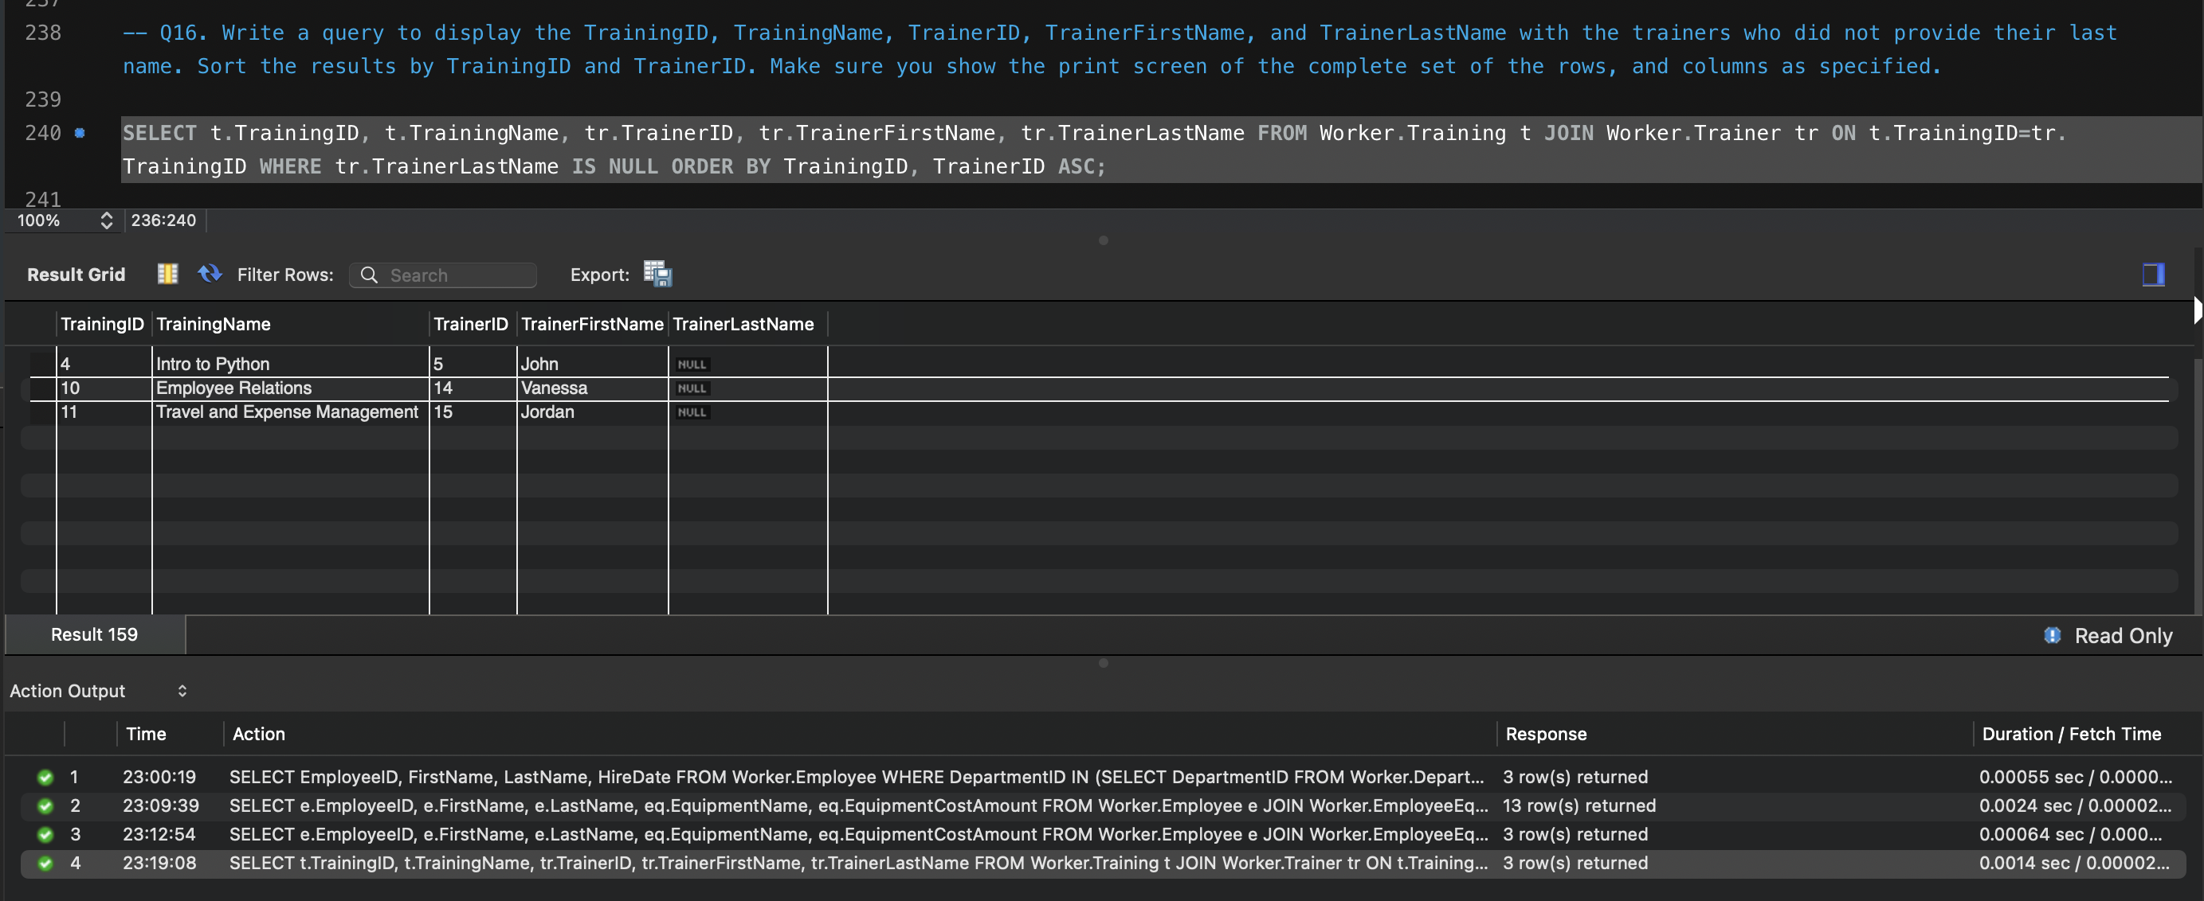

**Q17. Write a query to display the distinct list of equipments used by the current employees. Sort the output by EquipmentName. Make sure you show the print screen of the complete set of the rows, and columns as specified.**

|  |
| --- |
| **SELECT DISTINCT**  **e.EquipmentName**  **FROM**  **Worker.Equipment e**  **JOIN**  **Worker.EmployeeEquipment ee ON e.EquipmentID = ee.EquipmentID**  **ORDER BY EquipmentName ASC;** |

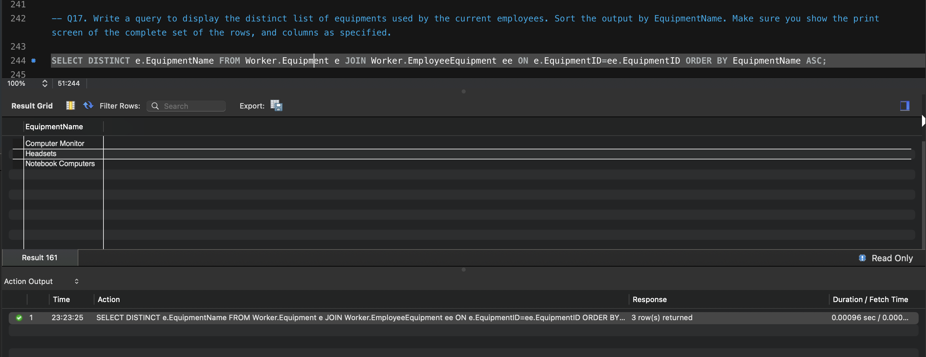

**Q18. Write a query to display the FirstName, LastName, TrainingName, and trainer(s) (with first and last name in two separate columns) for one of the employees. Sort the results by TrainingName and TrainerFirstName. Make sure you show the print screen of the complete set of the rows, and columns as specified.**

|  |
| --- |
| SELECT  e.FirstName,  e.LastName,  t.TrainingName,  tr.TrainerFirstName,  tr.TrainerLastName  FROM  Worker.Employee e  JOIN  Worker.EmployeeTraining et  JOIN  Worker.Training t  JOIN  Worker.Trainer tr ON e.EmployeeID = et.EmployeeID  AND et.TrainingID = t.TrainingID  AND tr.TrainingID = t.TrainingID  WHERE  e.EmployeeID = 3  ORDER BY TrainingName , TrainerFirstName ASC; |

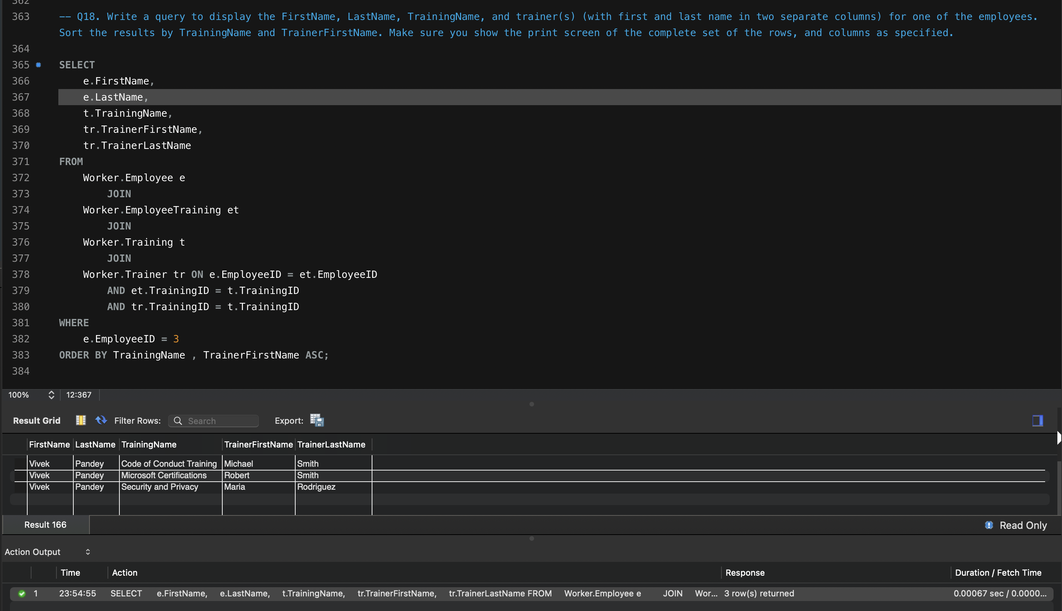

**Q19. Write a query to display the EmployeeID, FirstName, LastName, DepartmentID, DepartmentName, EquipmentID, EquipmentName for all employees. Sort the results by EmployeeID, DepartmentID, and EquipmentID. Make sure you show the print screen of the complete set of the rows, and columns as specified.**

|  |
| --- |
| **SELECT**  **e.EmployeeID,**  **e.FirstName,**  **e.LastName,**  **d.DepartmentID,**  **d.DepartmentNm AS DepartmentName,**  **eq.EquipmentID,**  **eq.EquipmentName**  **FROM**  **Worker.Employee e**  **JOIN**  **Worker.Department d**  **JOIN**  **Worker.Equipment eq**  **JOIN**  **Worker.EmployeeEquipment eeq ON e.EmployeeID = eeq.EmployeeID**  **AND e.DepartmentID = d.DepartmentID**  **AND eeq.EquipmentID = eq.EquipmentID**  **ORDER BY EmployeeID , DepartmentID , EquipmentID ASC;** |

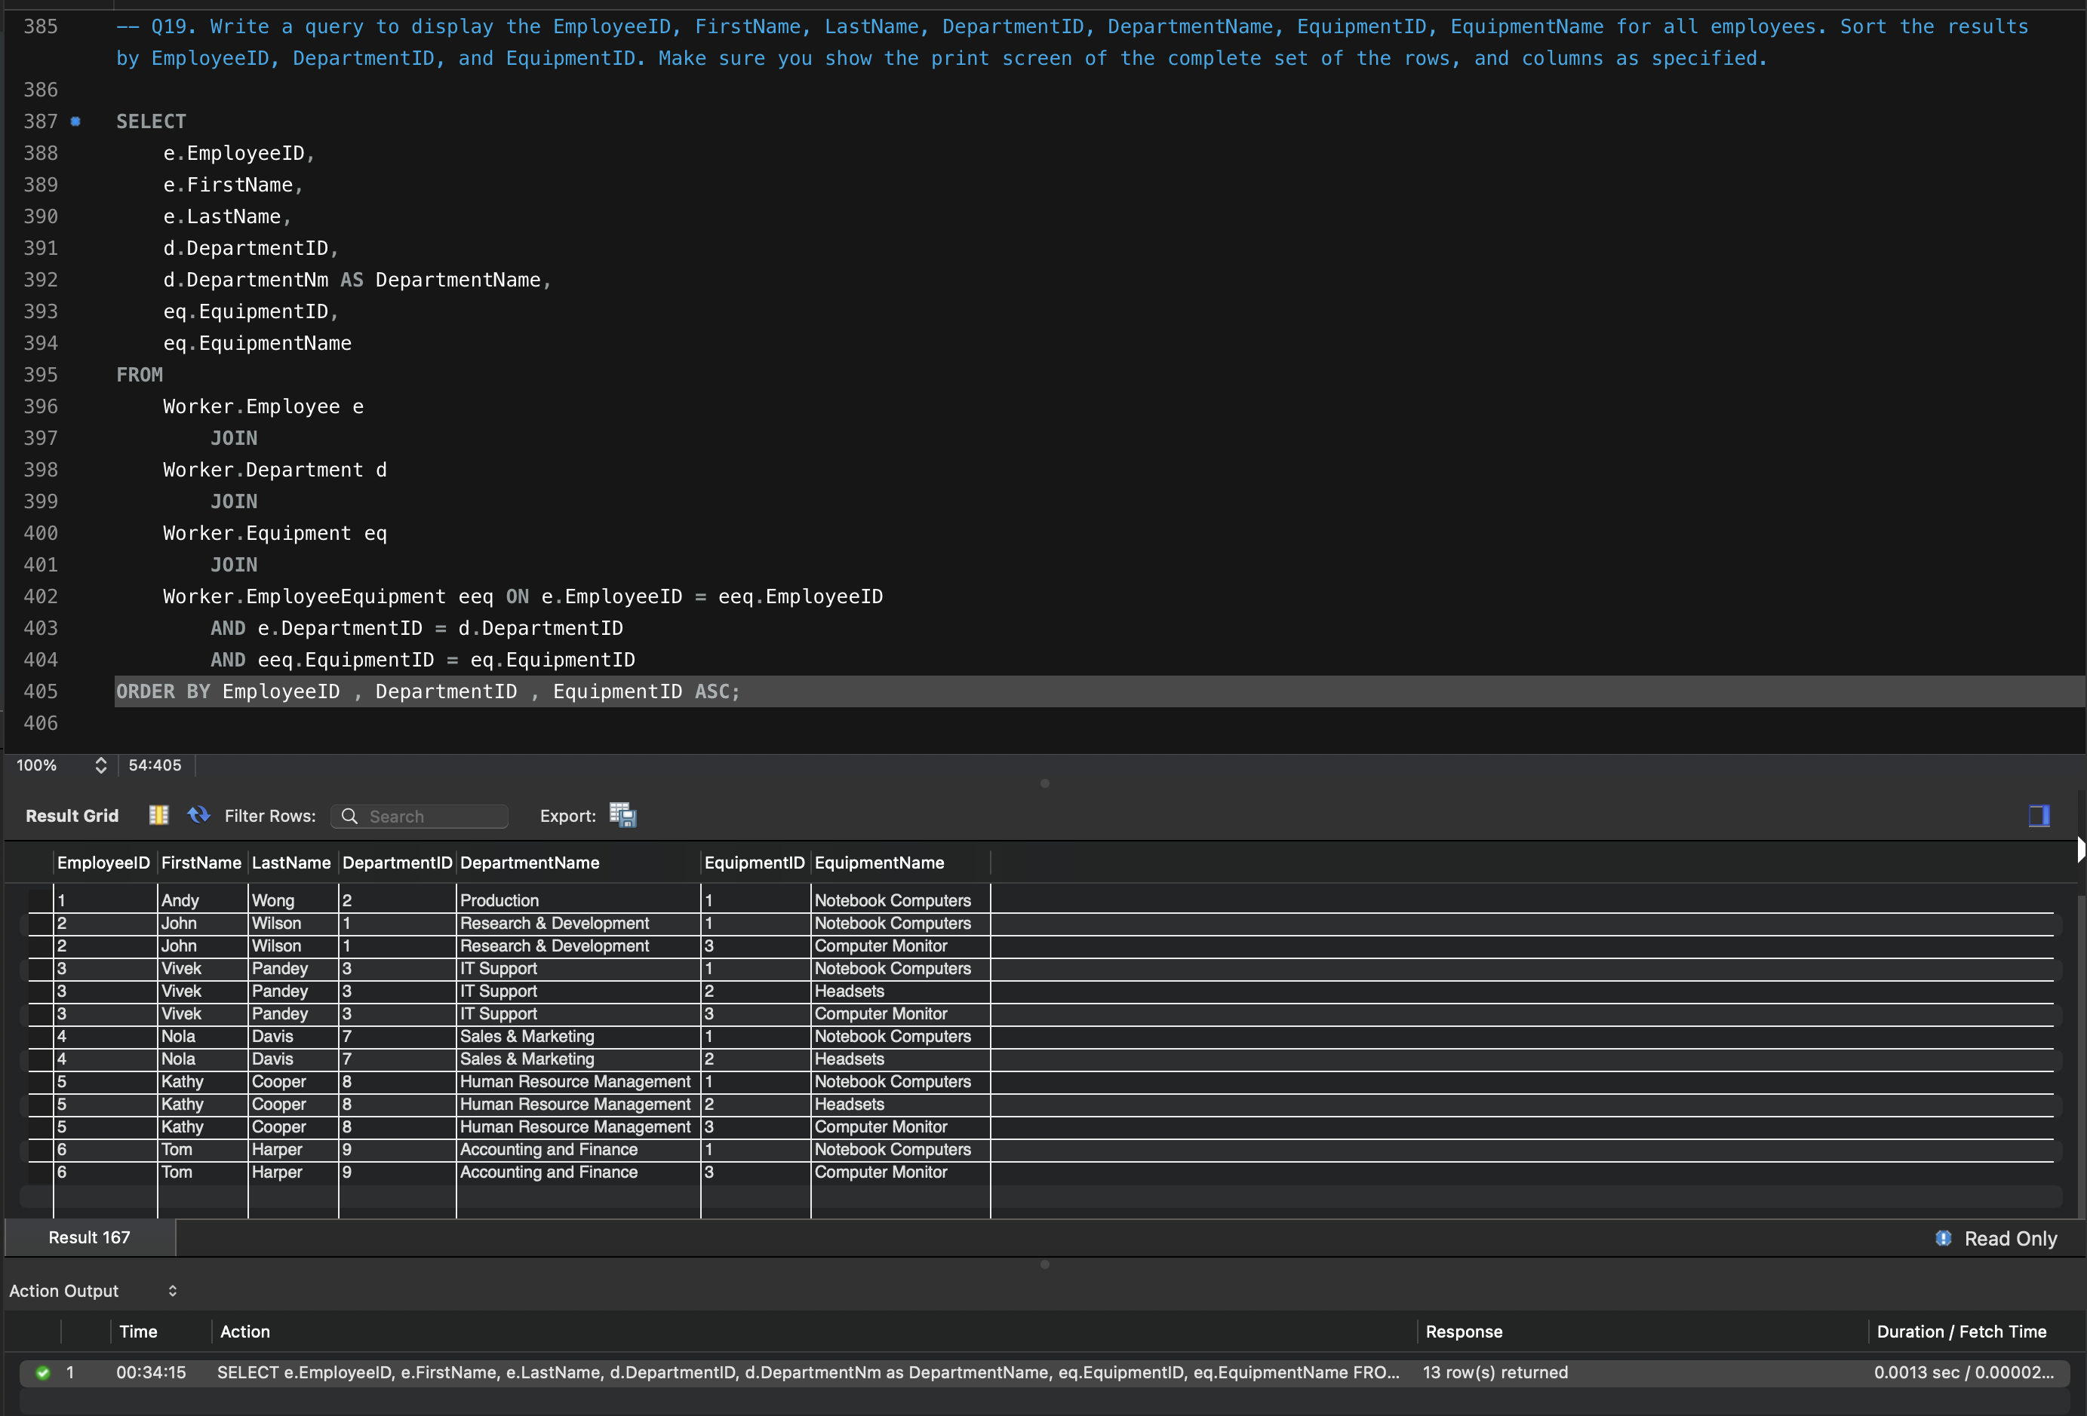

**Q20. Write a query to display the EmployeeID, FirstName, LastName, DepartmentID, DepartmentName, TrainingID, TrainingName for all employees. Sort the results by EmployeeID, DepartmentID, and TrainingID. Make sure you show the print screen of the complete set of the rows, and columns as specified.**

|  |
| --- |
| **SELECT**  **e.EmployeeID,**  **e.FirstName,**  **e.LastName,**  **d.DepartmentID,**  **d.DepartmentNm AS DepartmentName,**  **t.TrainingID,**  **t.TrainingName**  **FROM**  **Worker.Employee e**  **JOIN**  **Worker.Department d**  **JOIN**  **Worker.Training t**  **JOIN**  **Worker.EmployeeTraining et ON e.EmployeeID = et.EmployeeID**  **AND e.DepartmentID = d.DepartmentID**  **AND et.TrainingID = t.TrainingID**  **ORDER BY EmployeeID , DepartmentID , TrainingID ASC;** |

